1. Patient & Staff Login
The admin workflow begins on the Bundoora Family Clinic home page. The Patient & Staff Login option is used to open the sign-in area for authorised clinic users.
1. Open the Bundoora Family Clinic home page.
2. Select Patient & Staff Login.
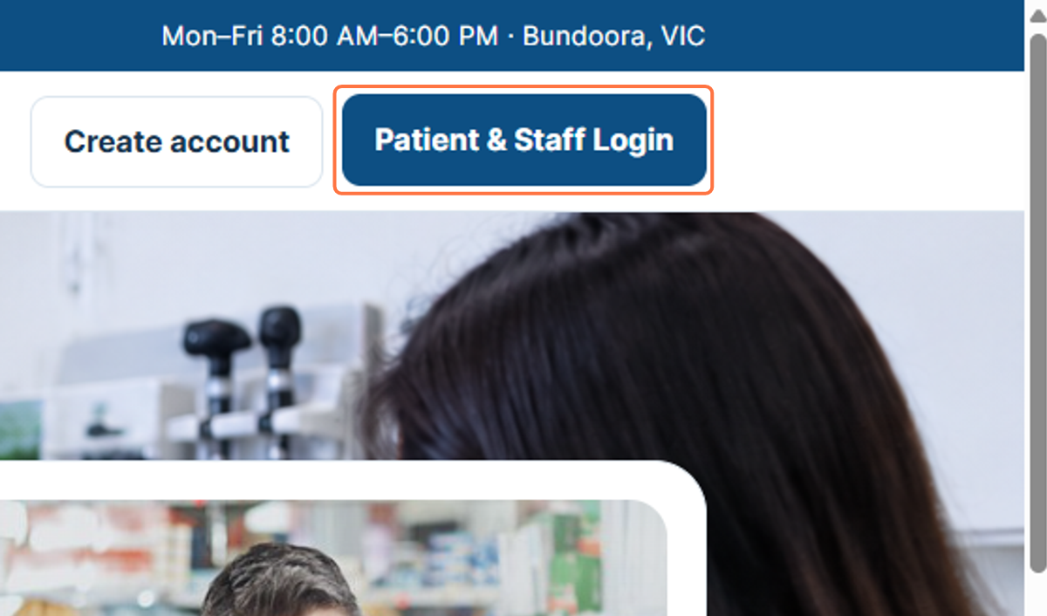
Figure 1: Opening Patient & Staff Login

2. Signing In - Email Address
On the sign-in page, the administrator enters the admin account email address shown in the workflow. This identifies the account that will be used for authentication.
3. Select the Email address field.
4. Enter "admin@bundoora.test".
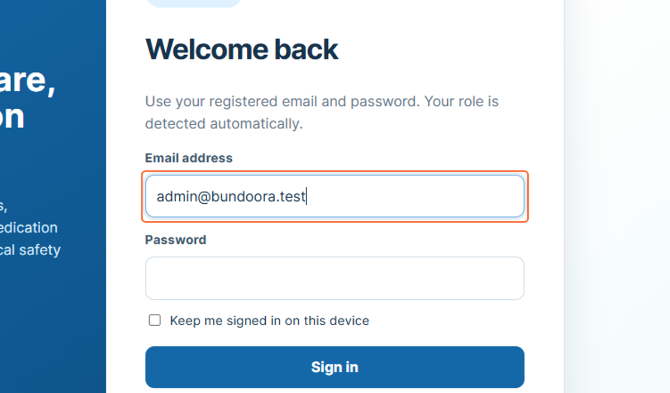
Figure 2: Entering the administrator email address

3. Signing In - Password
After the email address has been entered, the administrator enters the password for the account. The password is displayed as masked characters on the screen.
5. Select the Password field.
6. Enter the password for the administrator account.
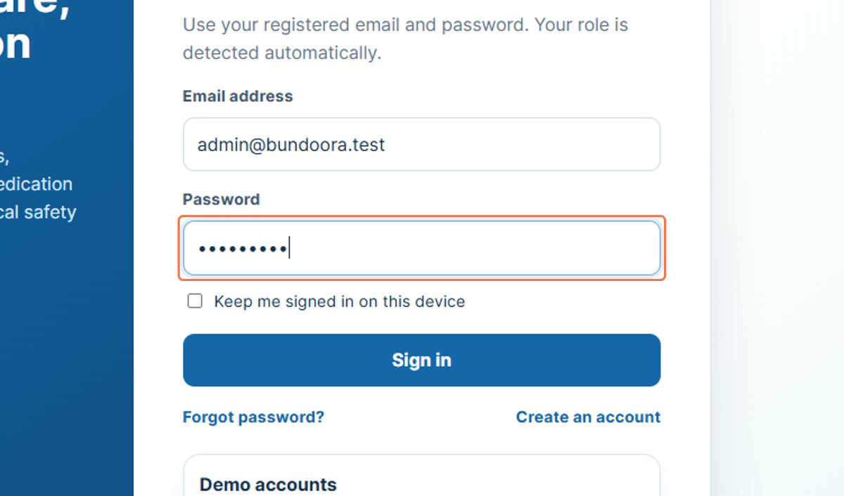
Figure 3: Entering the administrator password

4. Signing In - Submit Credentials
Selecting Sign in submits the entered administrator credentials. When the credentials are accepted, the system opens the administrator area.
7. Check that the email address and password fields are completed.
8. Select Sign in.
9. Wait for the Admin Dashboard to load.
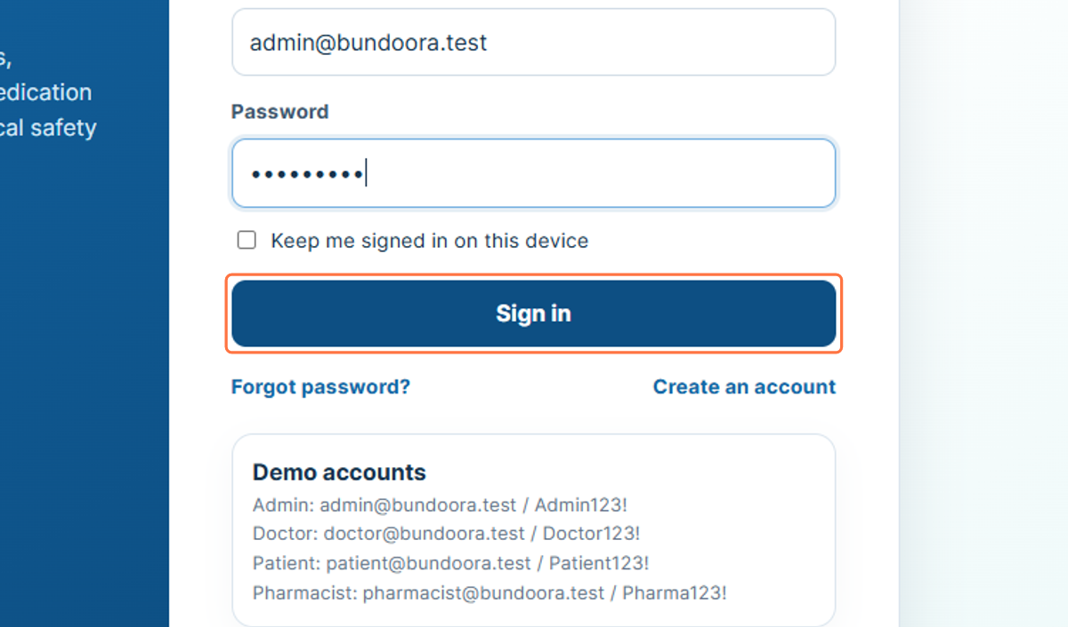
Figure 4: Selecting Sign in

5. Overview
The Overview page is the main administrator dashboard. It provides a system-wide view and gives access to the administration functions available from the left navigation menu.
10. Select Overview from the sidebar.
11. Review the dashboard information shown on the page.
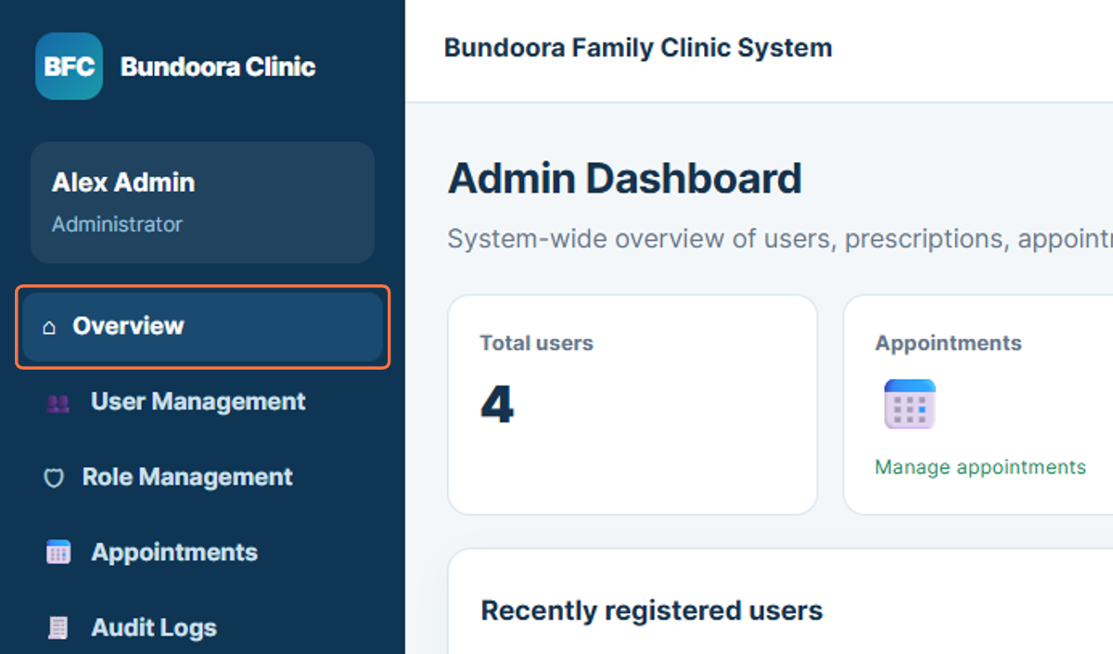
Figure 5: Admin Dashboard overview

6. User Management
User Management opens the area used to review and manage system accounts. The page shown in the workflow lists clinic users and provides account-related administration options.
12. Select User Management from the sidebar.
13. Review the available system accounts and user information.
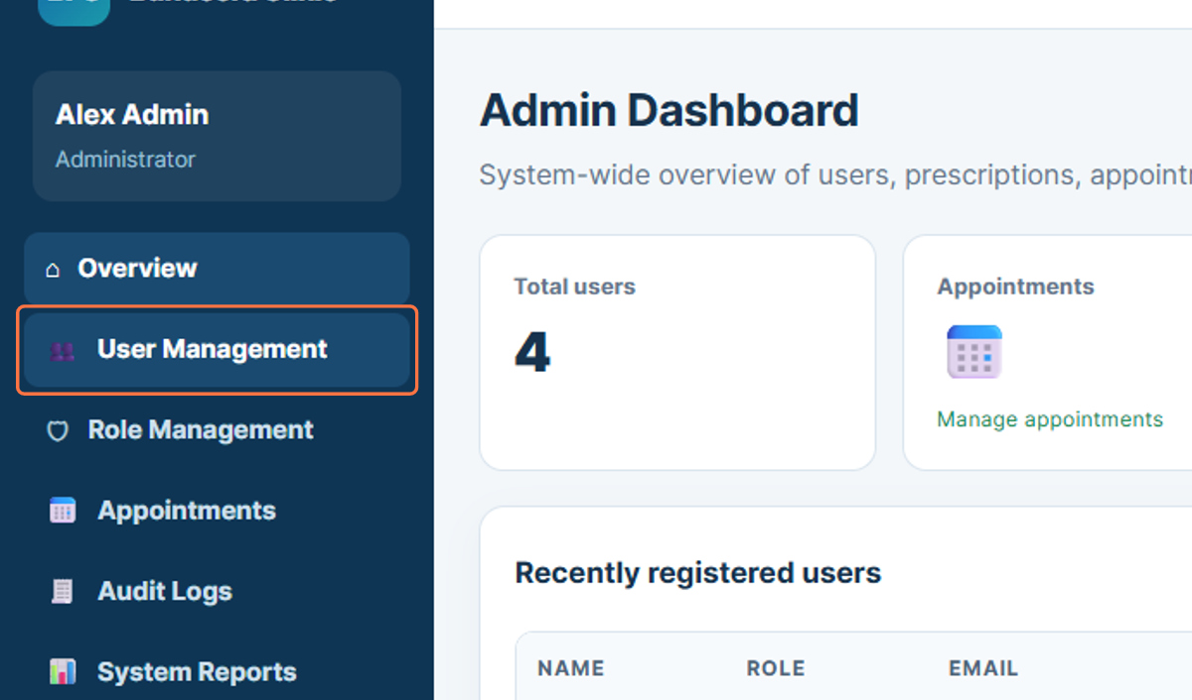
Figure 6: Opening User Management

7. Role Management
Role Management displays the configured role-based access model. The workflow shows roles such as Administrator and Doctor together with their access responsibilities.
14. Select Role Management from the sidebar.
15. Review the configured roles and access model.
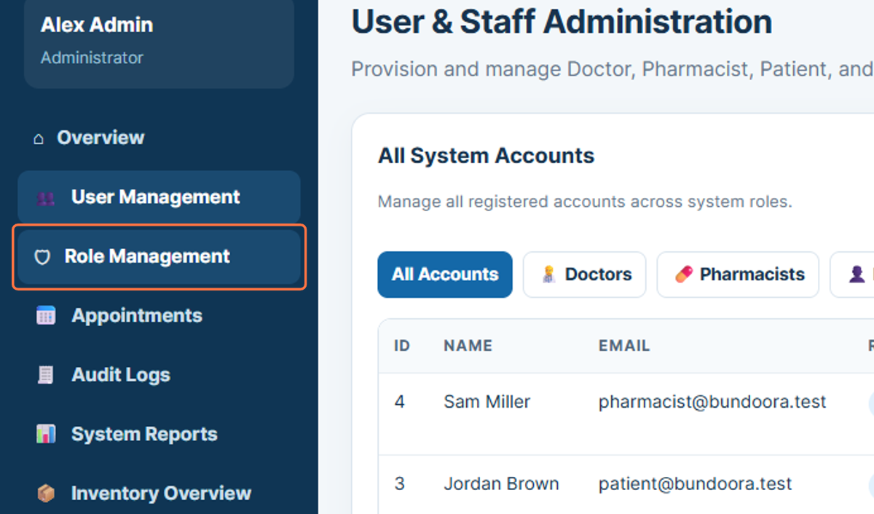
Figure 7: Opening Role Management

8. Appointments
The Appointments section allows the administrator to review appointment information recorded in the system. The page presents appointment totals and appointment details.
16. Select Appointments from the sidebar.
17. Review the appointment information displayed on the page.
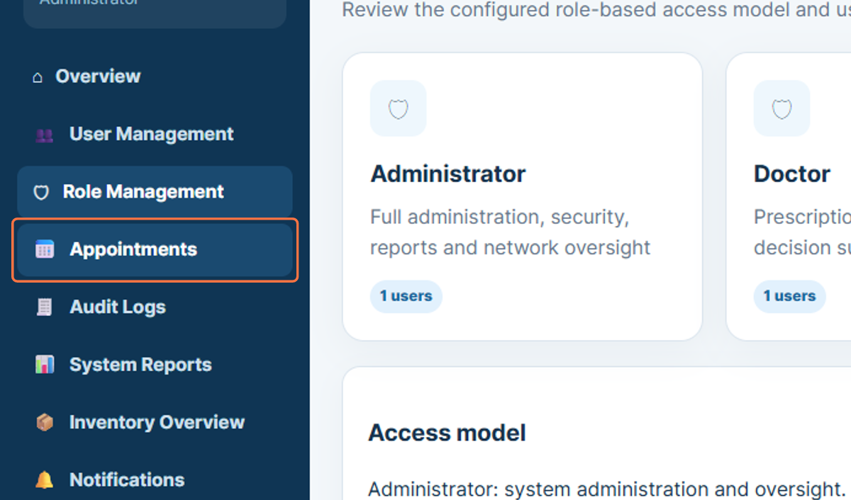
Figure 8: Opening Appointments

9. Audit Logs
Audit Logs provides a record of system activity for administrative review. The workflow shows logged events with information such as date, time, user and recorded action.
18. Select Audit Logs from the sidebar.
19. Review the recorded system activity.
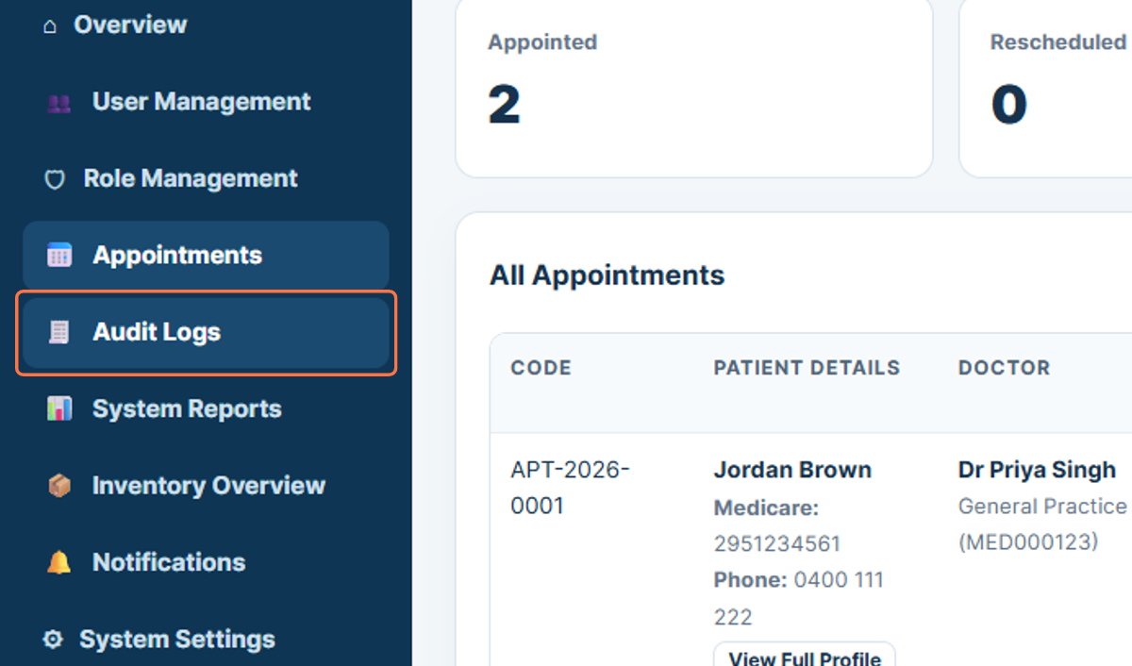
Figure 9: Opening Audit Logs

10. System Reports
System Reports provides reporting and export functions for administrative information. The workflow shows an export area where a user report can be downloaded as a CSV file.
20. Select System Reports from the sidebar.
21. Review the available report and export options.
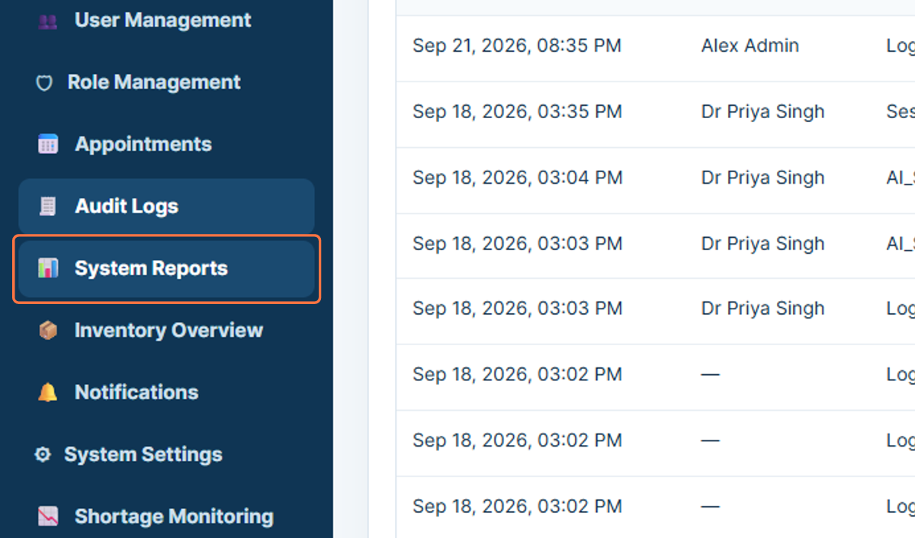
Figure 10: Opening System Reports

11. Inventory Overview
Inventory Overview displays medicine information available to the administrator. The page shown in the workflow provides a list of medicines and related inventory information.
22. Select Inventory Overview from the sidebar.
23. Review the medicine and inventory information displayed.
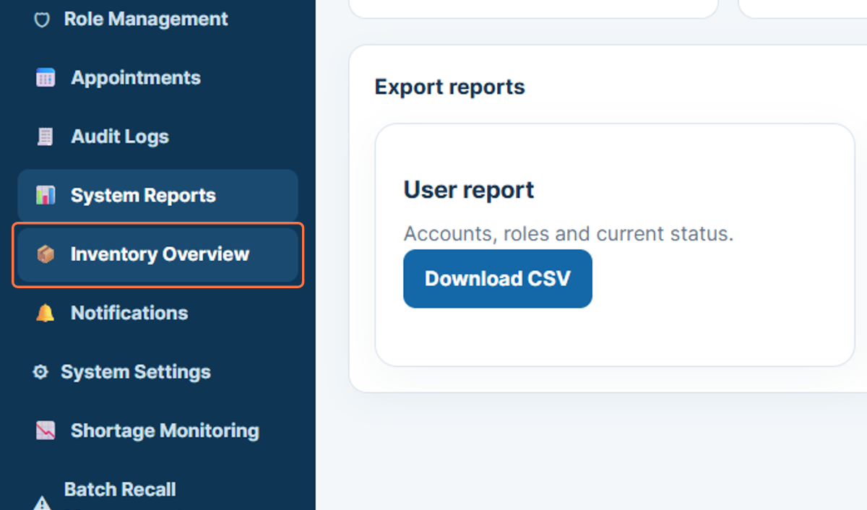
Figure 11: Opening Inventory Overview

12. Notifications
The Notifications section displays system notification records. The workflow shows notification entries associated with system events such as stock or medication-related activity.
24. Select Notifications from the sidebar.
25. Review the available notification records.
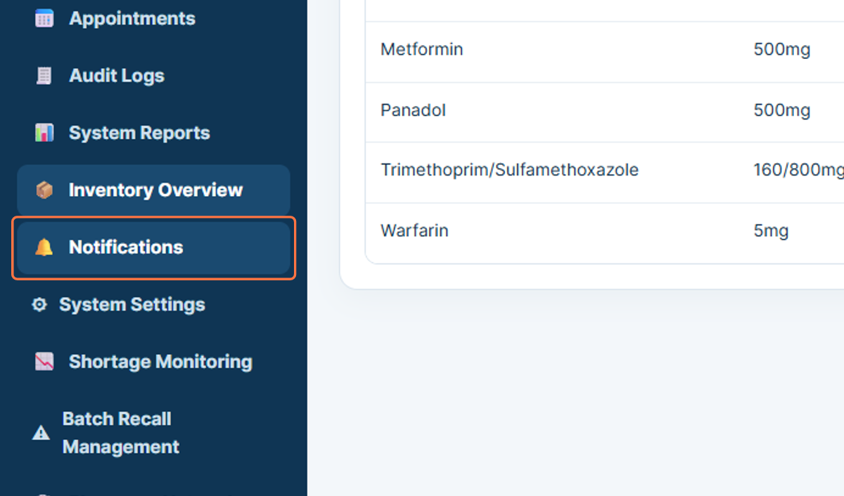
Figure 12: Opening Notifications

13. System Settings
System Settings opens the configuration area available to the administrator. The workflow shows a session-related setting where an automatic logout period can be configured.
26. Select System Settings from the sidebar.
27. Review the available system configuration settings.
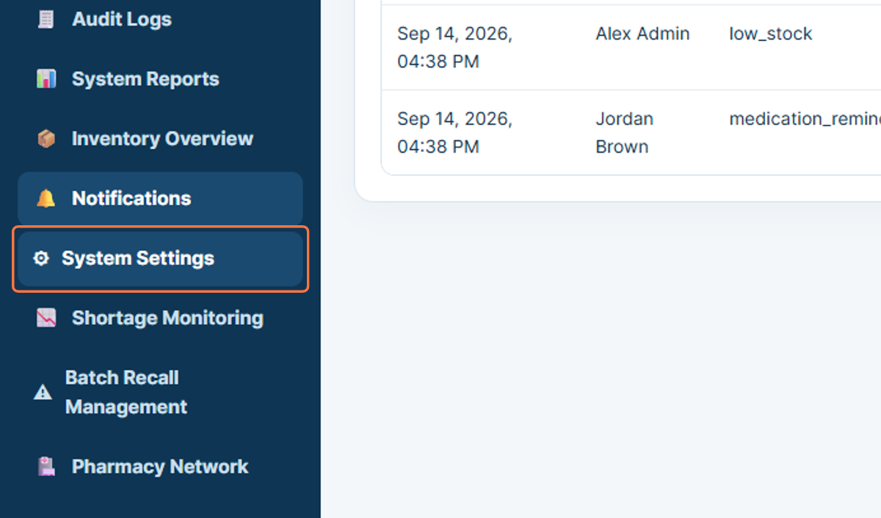
Figure 13: Opening System Settings

14. Shortage Monitoring
Shortage Monitoring provides information used to review potential medicine shortages. The workflow also shows an Australian TGA shortage cross-reference section.
28. Select Shortage Monitoring from the sidebar.
29. Review the shortage monitoring information shown on the page.
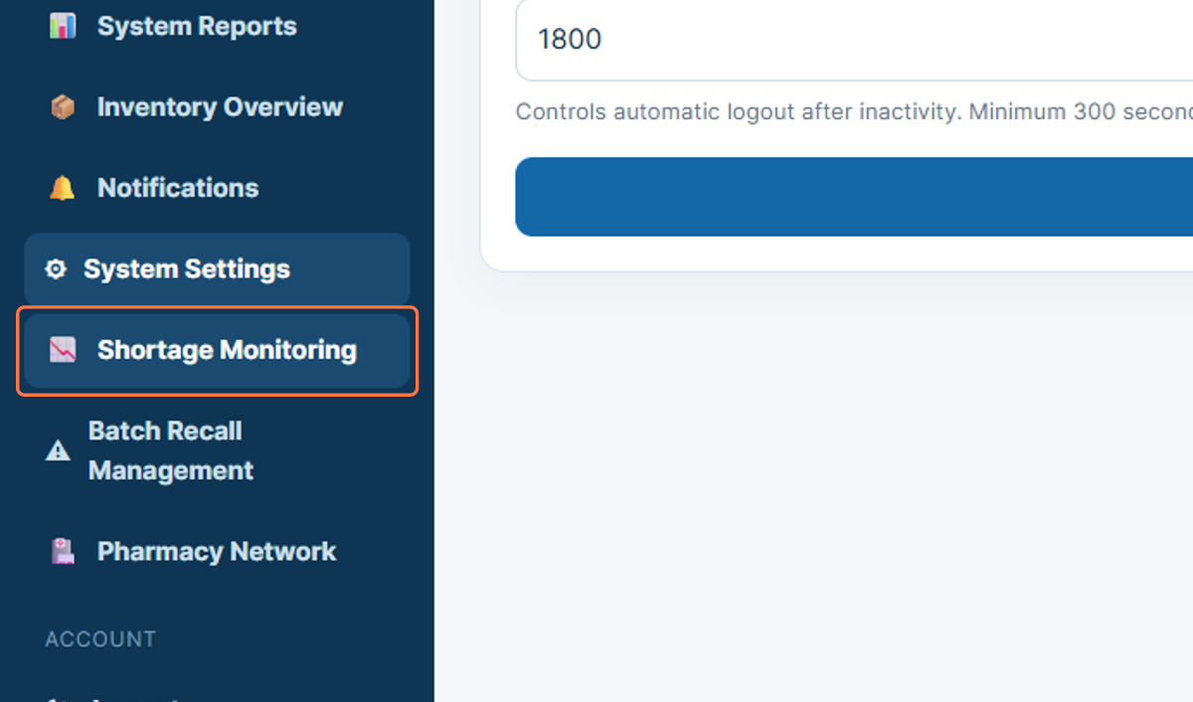
Figure 14: Opening Shortage Monitoring

15. Batch Recall Management
Batch Recall Management provides functions related to medicine batch recall and near-expiry stock. The workflow shows recall and quarantine functionality together with near-expiry redistribution information.
30. Select Batch Recall Management from the sidebar.
31. Review the batch recall and near-expiry information.
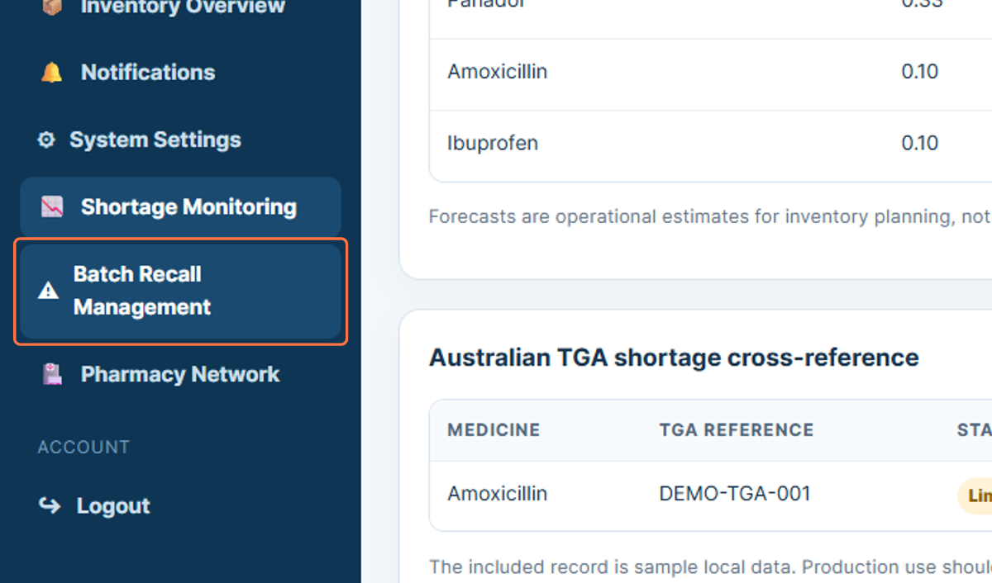
Figure 15: Opening Batch Recall Management

16. Pharmacy Network
Pharmacy Network opens the area containing partner pharmacy information. This section allows the administrator to review the pharmacy network information available in the system.
32. Select Pharmacy Network from the sidebar.
33. Review the pharmacy information displayed.
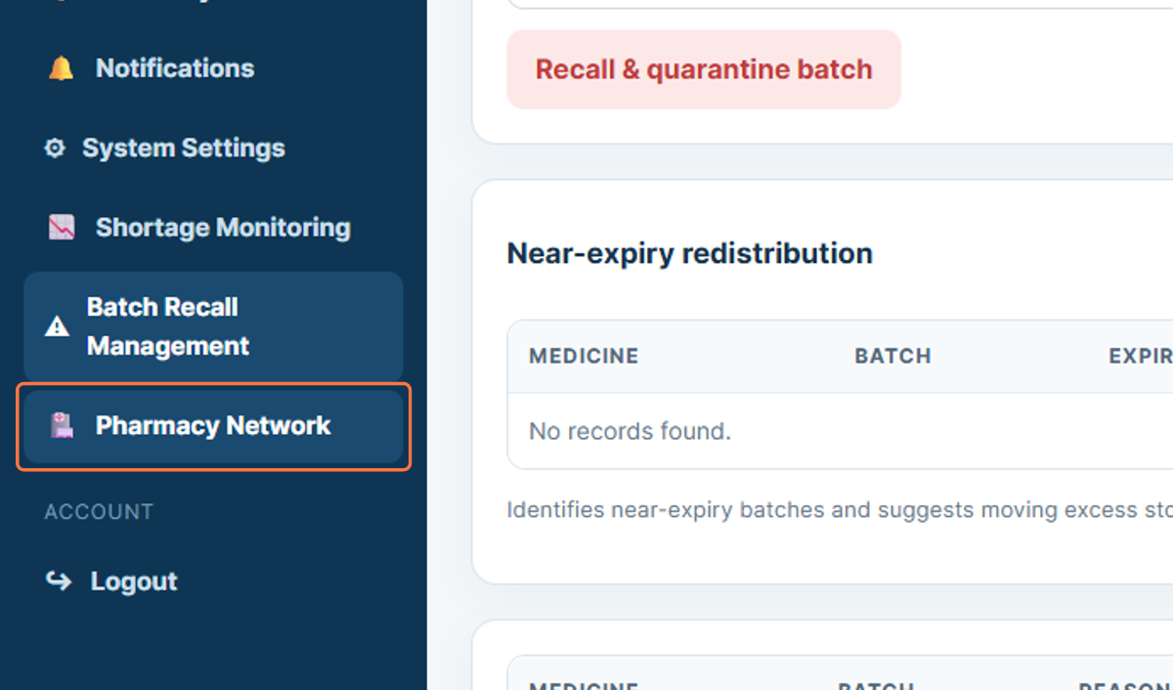
Figure 16: Opening Pharmacy Network

17. Session
The Session indicator is displayed in the upper area of the administrator interface. The workflow highlights the current session timer so that the signed-in user can monitor the active session.
34. Locate the Session indicator in the upper area of the page.
35. Review the displayed session time.
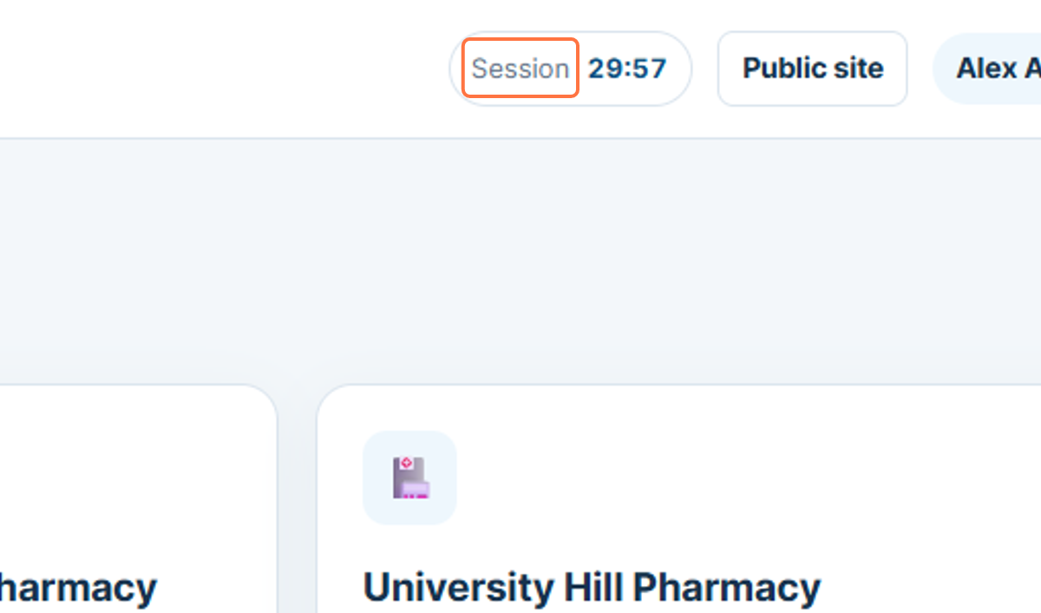
Figure 17: Administrator session indicator

18. Logout
Logout ends the current administrator session. Signing out after completing administration tasks helps prevent another person from continuing to use the active account.
36. Select Logout from the sidebar.
37. Confirm that the administrator session has ended.
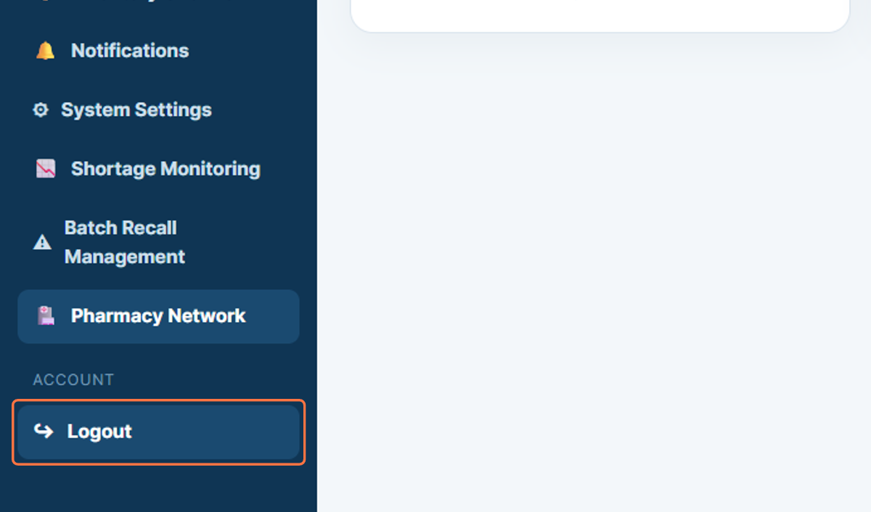
Figure 18: Logging out of the administrator portal

19. Signing In - Email Address
The pharmacist workflow begins on the Bundoora Family Clinic login page. The pharmacist enters the registered pharmacist email address in the Email address field so the system can identify the correct user account.
38. Open the Bundoora Family Clinic sign-in page.
39. Select the Email address field and enter the pharmacist account shown in the workflow: pharmacist@bundoora.test.
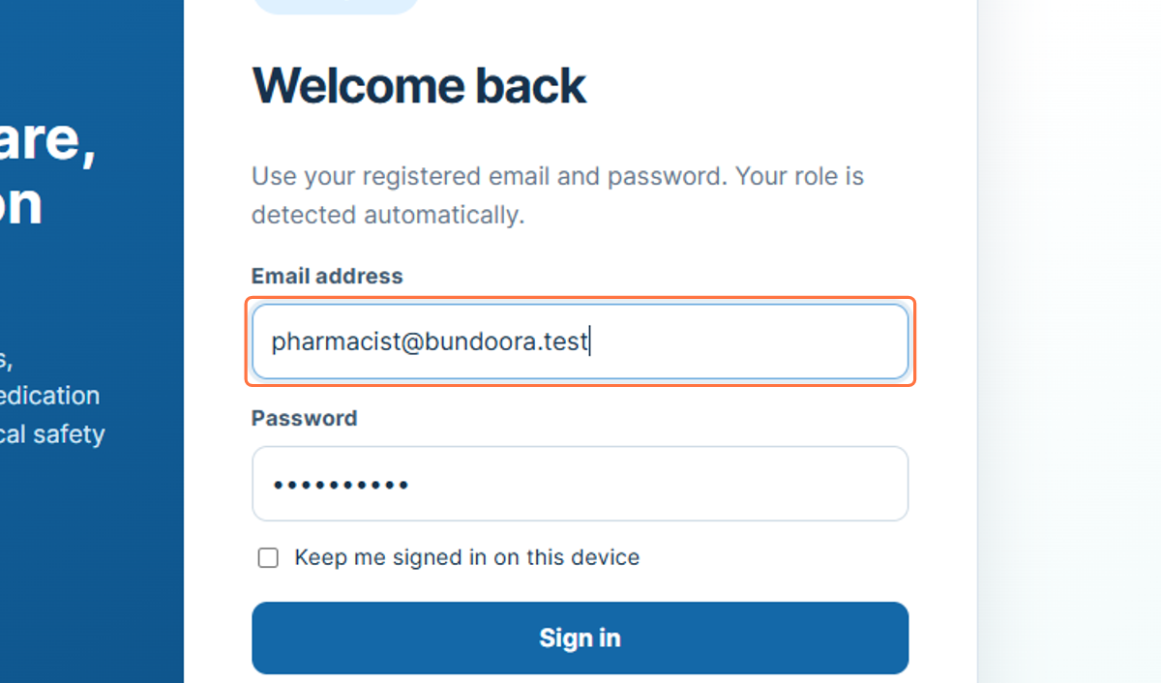
Figure 19: Entering the pharmacist email address

20. Signing In - Password
After the email address has been entered, the pharmacist provides the password for the account. The password is masked on screen to help protect the user credentials.
40. Select the Password field.
41. Enter the password associated with the pharmacist account.
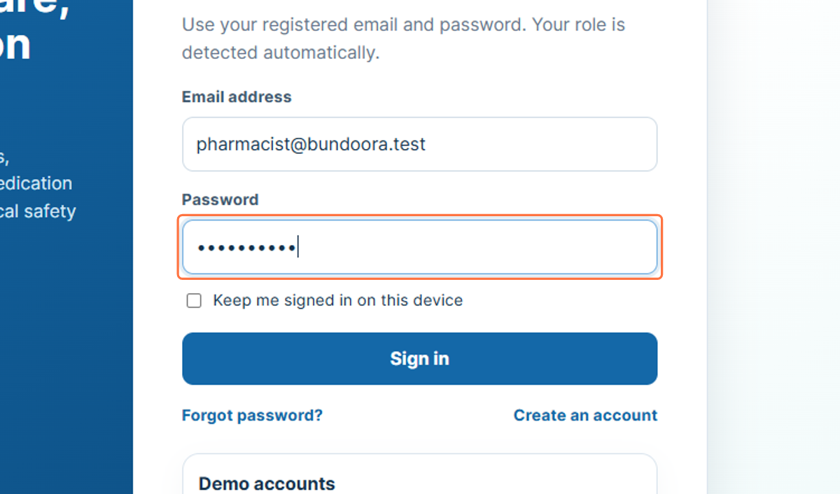
Figure 20: Entering the pharmacist account password

21. Signing In - Submit Credentials
Selecting Sign in submits the entered credentials for authentication. When the credentials are accepted, the system opens the Pharmacist Dashboard and provides access to pharmacist-specific functions.
42. Check that the email address and password fields are completed.
43. Select Sign in.
44. Wait for the Pharmacist Dashboard to load.
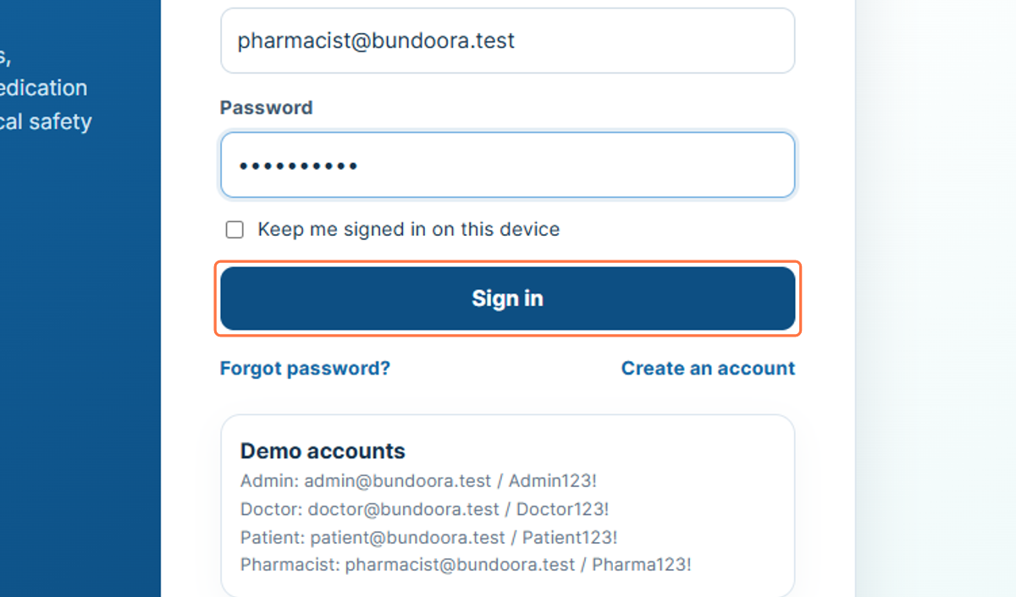
Figure 21: Selecting Sign in

22. Pharmacist Profile Area
The profile card in the left sidebar identifies the pharmacist currently signed in. In the workflow, the account is shown as Sam Miller with the role Pharmacist, allowing the user to confirm that the correct account is active.
45. Confirm the pharmacist name shown in the sidebar.
46. Confirm that the role displayed is Pharmacist.
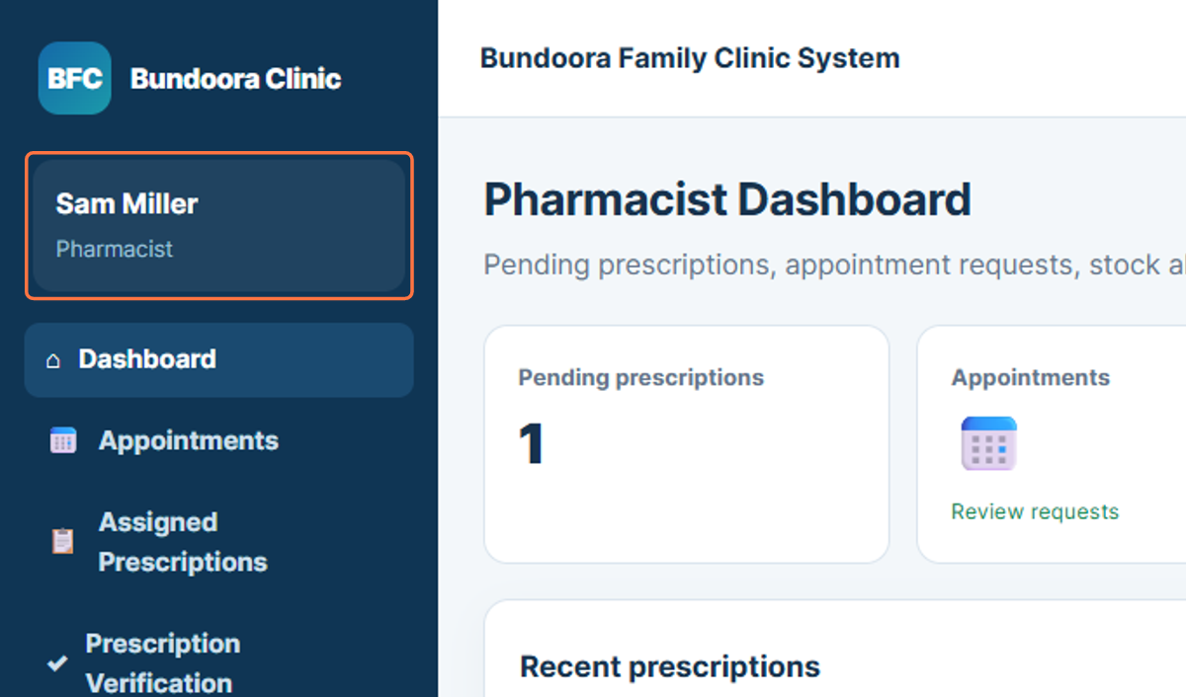
Figure 22: Pharmacist identity and role shown in the sidebar

23. Dashboard
The Pharmacist Dashboard is the main overview page for the pharmacist account. It provides summary information such as pending prescriptions, appointments, and recent prescription activity, and acts as the starting point for the pharmacist workflow.
47. Select Dashboard from the sidebar.
48. Review the summary information and recent prescription activity.
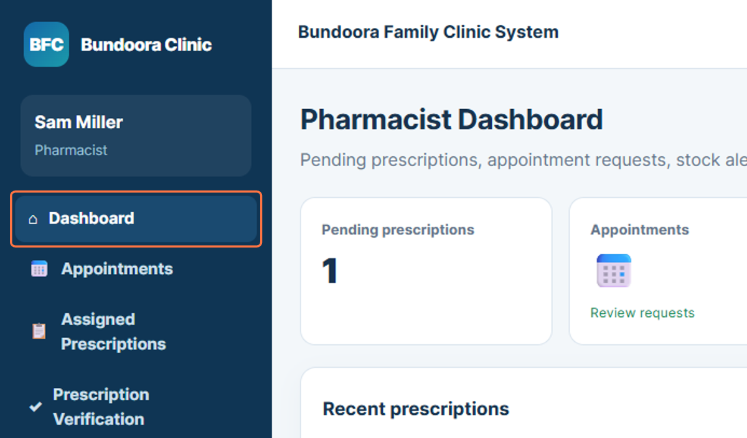
Figure 23: Pharmacist Dashboard navigation

24. Appointments
The Appointments section allows the pharmacist to review appointment-related information available in the system. This helps the pharmacist understand the current consultation activity before working with prescriptions and dispensing tasks.
49. Select Appointments from the sidebar.
50. Review the appointment information shown on the page.
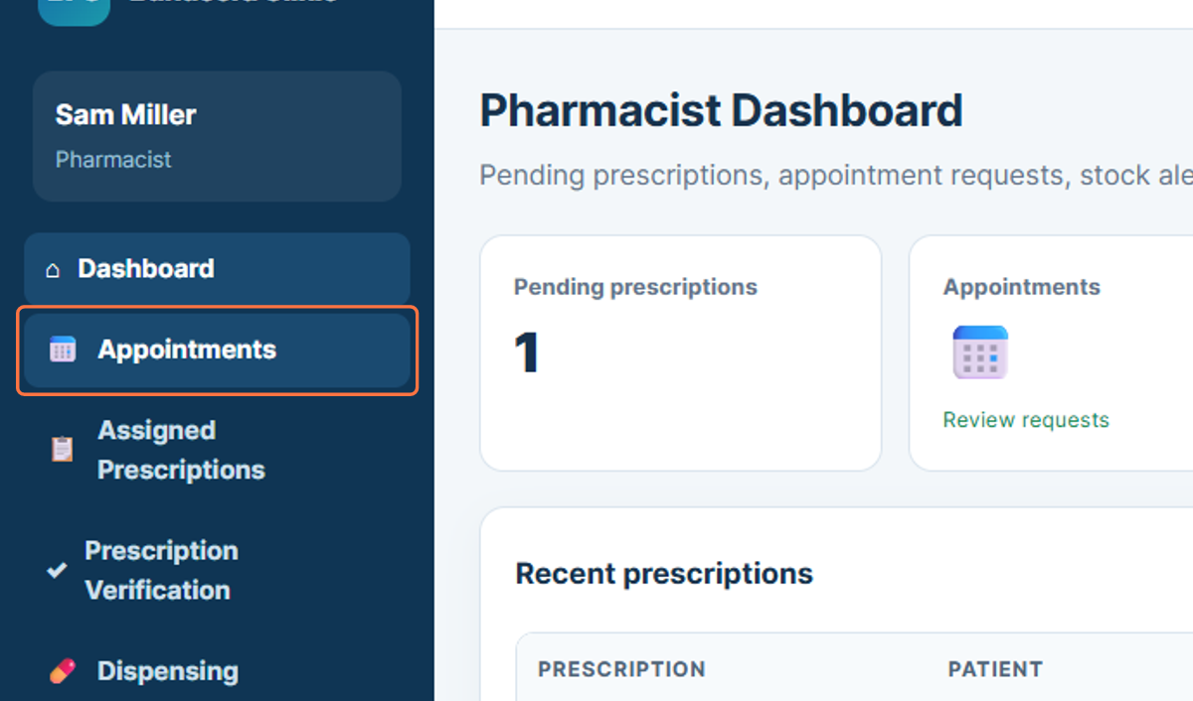
Figure 24: Opening Appointments

25. Assigned Prescriptions
Assigned Prescriptions provides access to prescriptions that are available for the pharmacist to review. The workflow shows prescription information linked with the patient and doctor details.
51. Select Assigned Prescriptions from the sidebar.
52. Review the prescriptions assigned for pharmacist action.
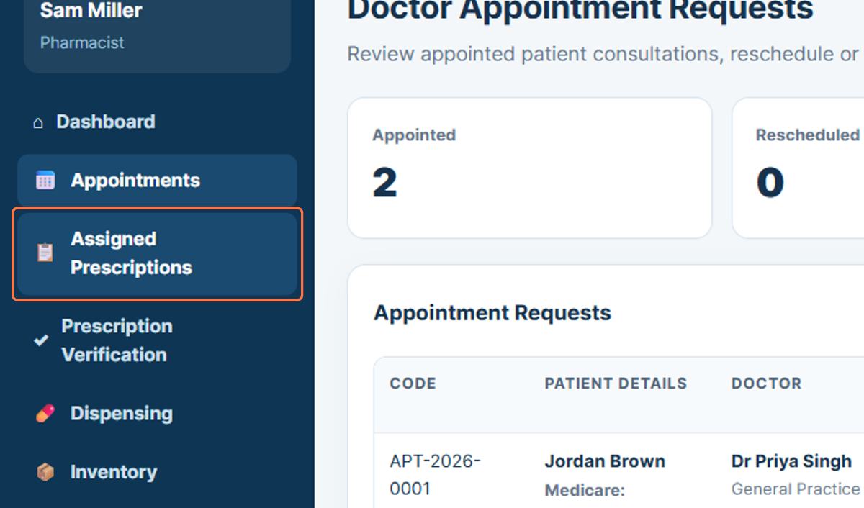
Figure 25: Opening Assigned Prescriptions

26. Prescription Verification
Prescription Verification is used to review prescription records before medication is dispensed. This step supports the pharmacist in checking the prescription information provided by the doctor.
53. Select Prescription Verification from the sidebar.
54. Review the available prescription and patient details before continuing.
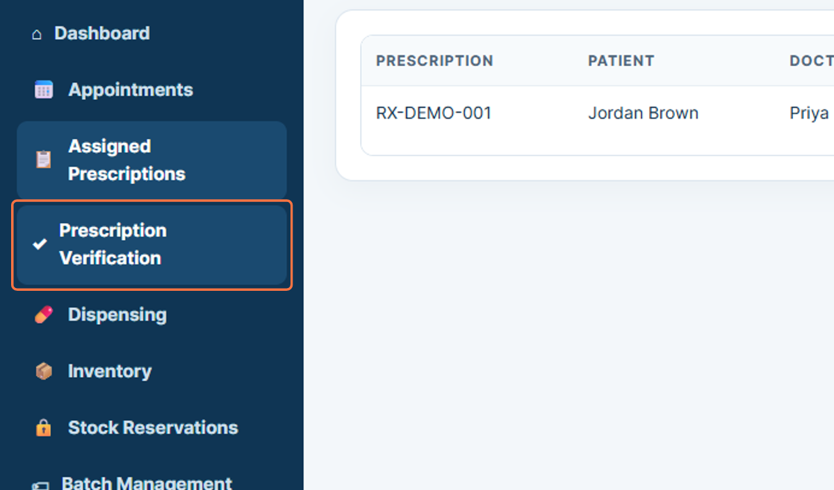
Figure 26: Opening Prescription Verification

27. Dispensing
The Dispensing section is used to process medication dispensing after a prescription has been reviewed. The workflow shows fields for selecting a prescription item and batch information.
55. Select Dispensing from the sidebar.
56. Choose the relevant prescription and review the dispensing information.
57. Enter or select the appropriate batch details when required.
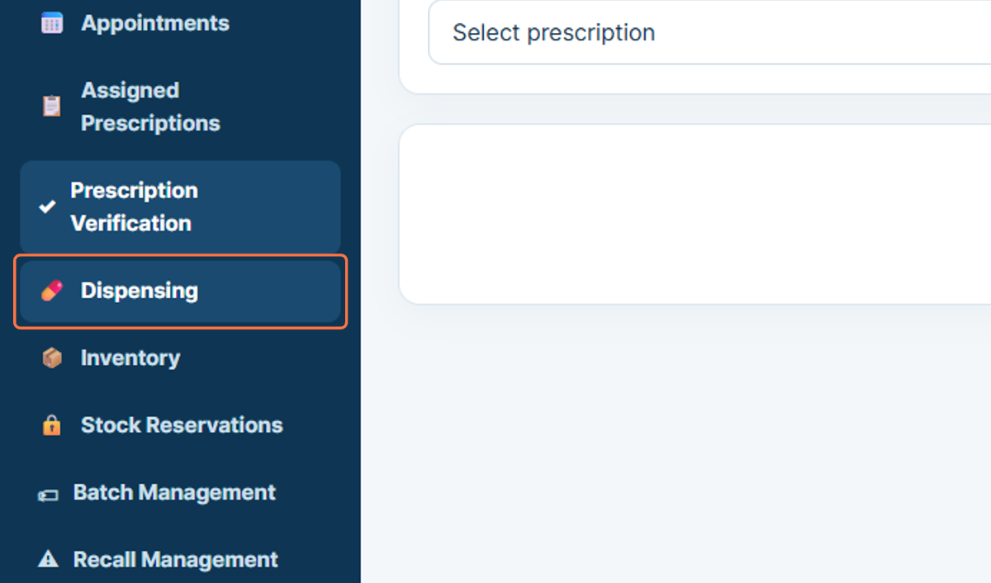
Figure 27: Opening Dispensing

28. Inventory
Inventory provides the pharmacist with a view of available medicines and stock information. This section supports checking stock levels before or during the dispensing process.
58. Select Inventory from the sidebar.
59. Review the available medicines and stock quantities.
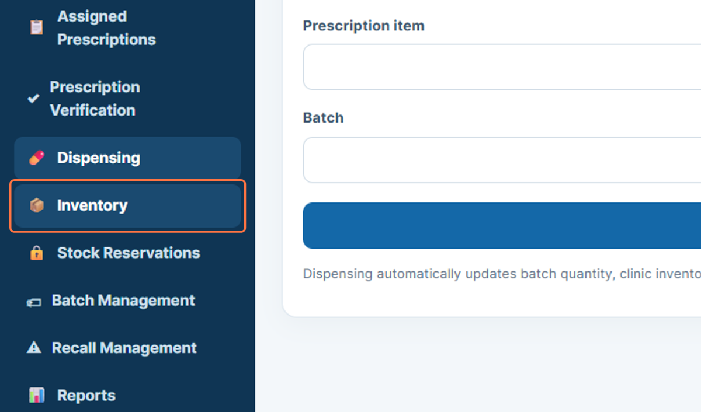
Figure 28: Opening Inventory

29. Stock Reservations
Stock Reservations displays medicines or quantities that have been reserved within the system. This helps prevent the same stock from being allocated to multiple requests.
60. Select Stock Reservations from the sidebar.
61. Review the current reservation information.
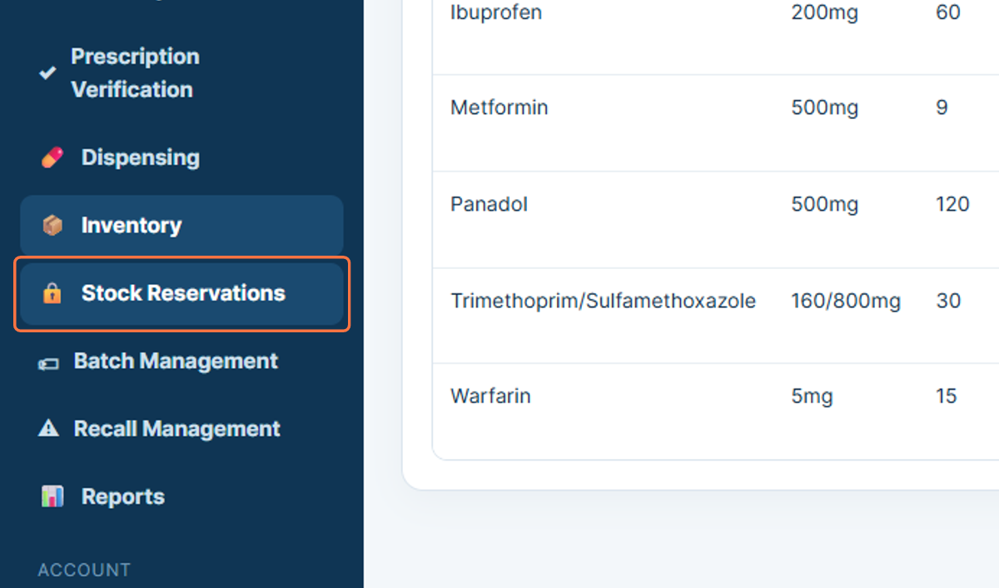
Figure 29: Opening Stock Reservations

30. Batch Management
Batch Management provides access to medicine batch-related information. This area is used for reviewing and managing batch details that support safe inventory and dispensing operations.
62. Select Batch Management from the sidebar.
63. Review the available batch information.
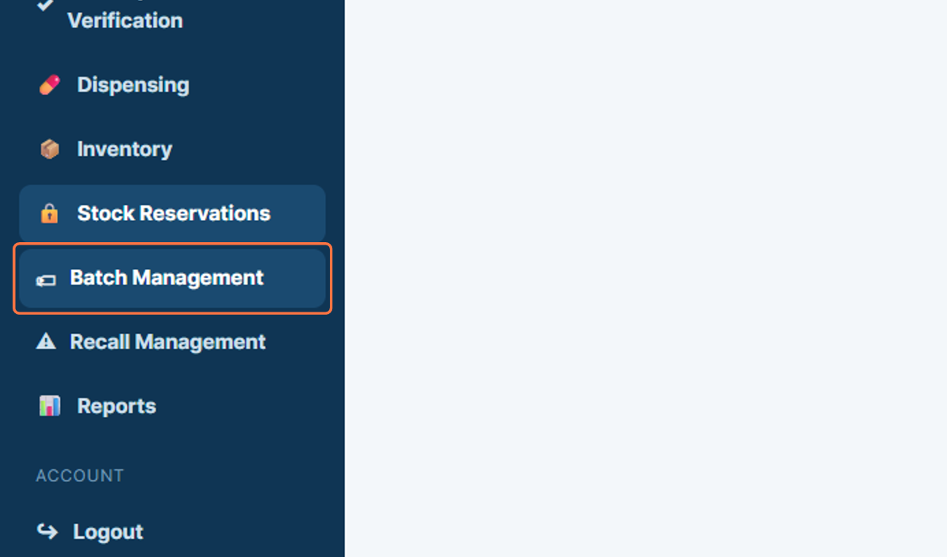
Figure 30: Opening Batch Management

31. Recall Management
Recall Management supports the review of medicines or batches affected by a recall. The workflow shows medicine names, batch identifiers, and stock quantities that may require pharmacist attention.
64. Select Recall Management from the sidebar.
65. Review the listed medicines and batch information for recall-related actions.
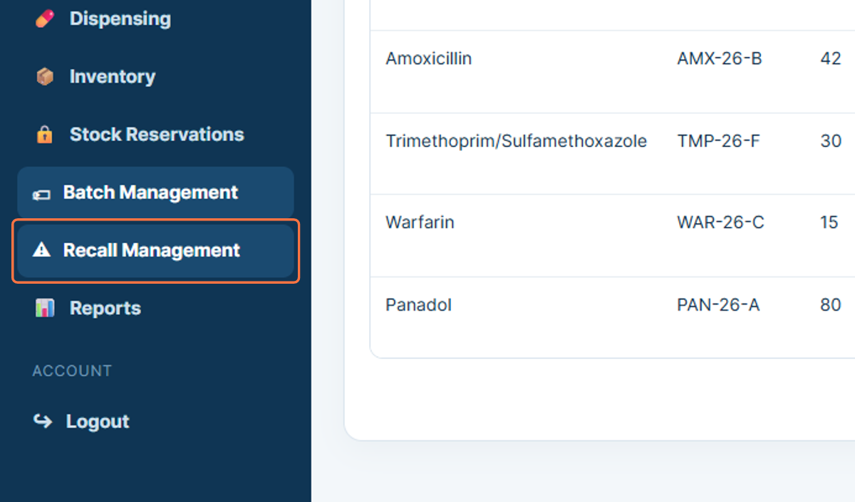
Figure 31: Opening Recall Management

32. Reports
The Reports section provides access to pharmacist-related reporting information. It can be used to review system records associated with prescription, dispensing, inventory, or other pharmacist activities.
66. Select Reports from the sidebar.
67. Review the available report information.
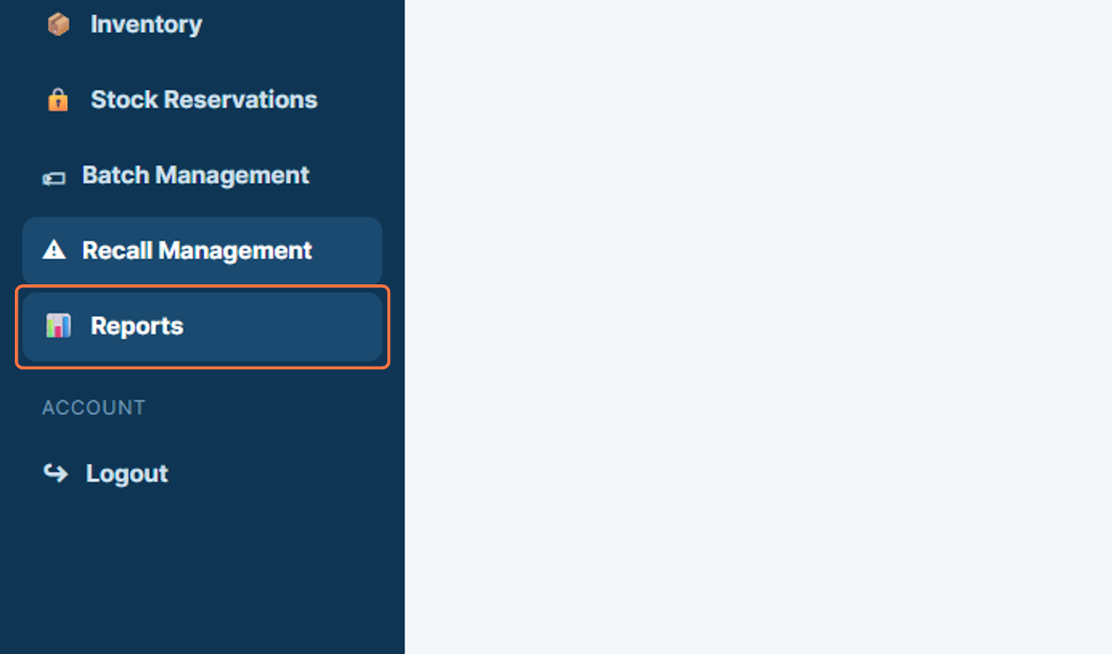
Figure 32: Opening Reports

33. Logout
Logout ends the current pharmacist session. Signing out after completing dispensing and inventory tasks is important, especially when the system is used on a shared clinic workstation.
68. Select Logout from the sidebar.
69. Confirm that the pharmacist session has ended.
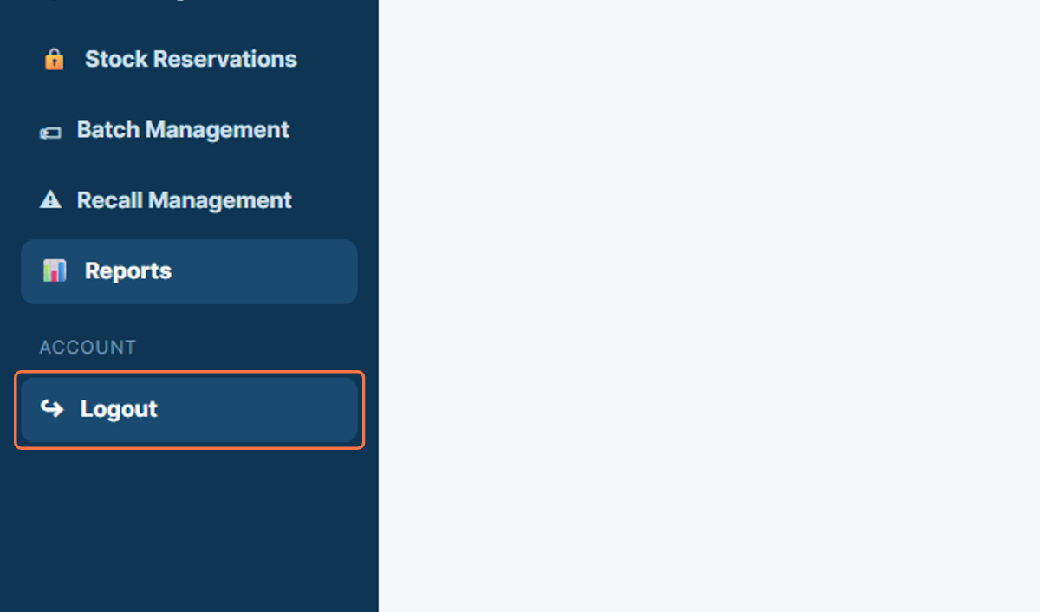
Figure 33: Logging out of the Pharmacist Portal

34. Close the Floating Panel
The public website workflow begins on the Bundoora Family Clinic home page. A floating panel is visible near the lower area of the page, and it can be closed to provide a clearer view of the website content.
70. Open the Bundoora Family Clinic home page.
71. Select the Close button on the floating panel.
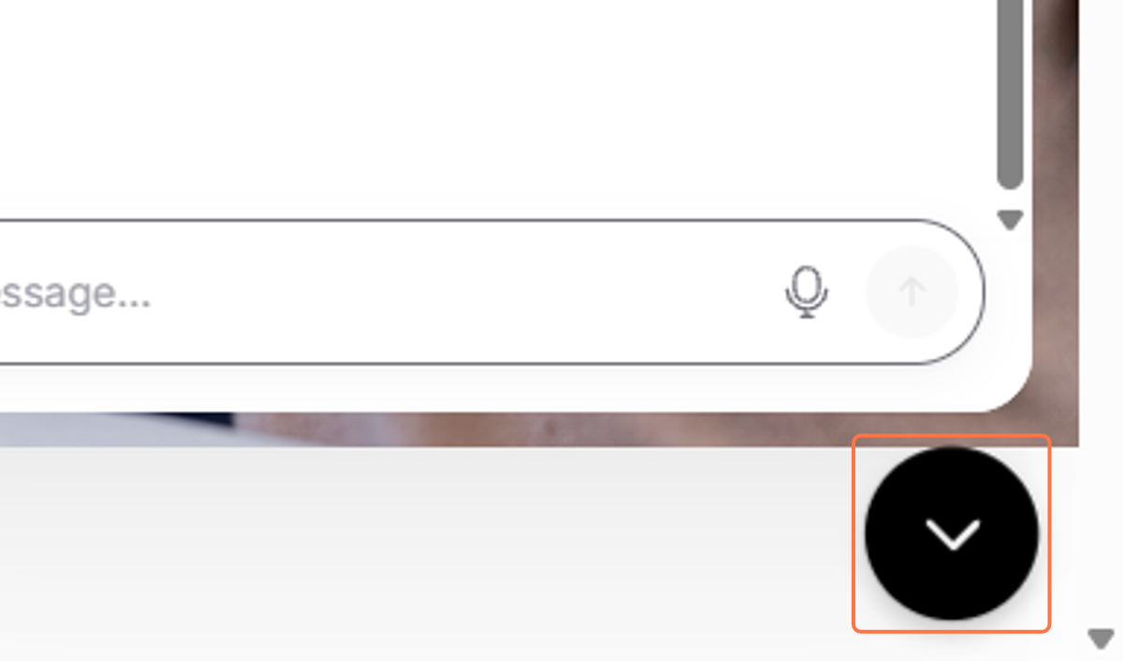
Figure 34: Closing the floating panel

35. Clinic Support Message
The top section of the public website displays the message “Trusted family healthcare & digital medication support”. This message introduces the purpose of the website and highlights the clinic’s focus on family healthcare and digital medication services.
72. Review the support message displayed at the top of the page.
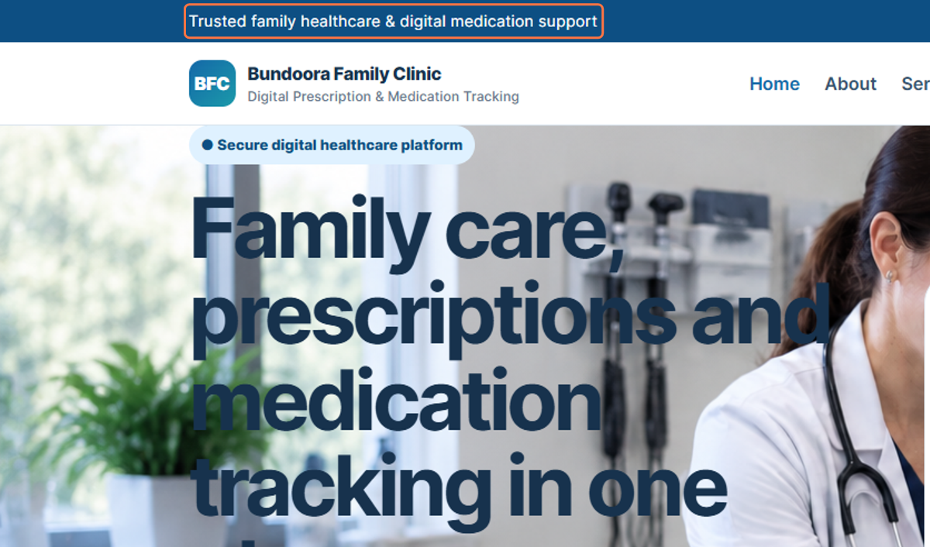
Figure 35: Clinic support message

36. Clinic Opening Hours
The public website displays the clinic opening hours and location in the top information bar. In the workflow, this information is shown as Monday to Friday, 8:00 AM to 6:00 PM, Bundoora, Victoria.
73. Locate the clinic information bar.
74. Review the displayed opening hours and location.
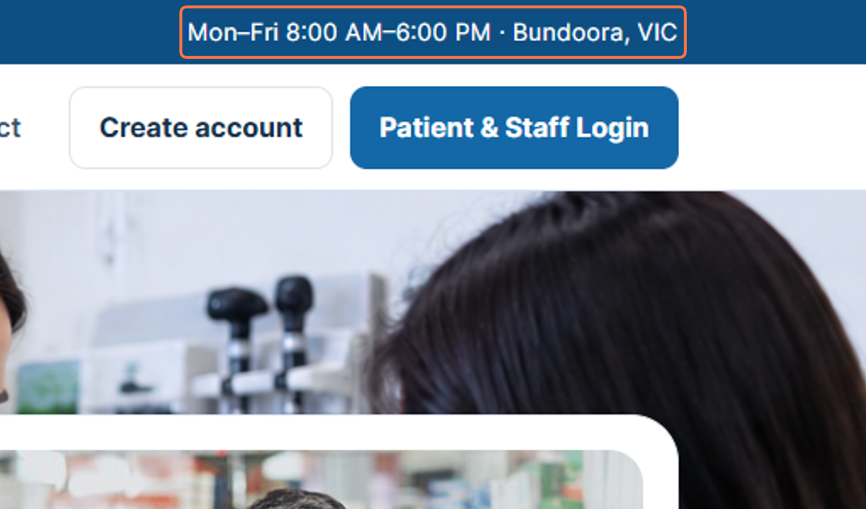
Figure 36: Clinic opening hours and location

37. Bundoora Family Clinic Logo
The Bundoora Family Clinic logo and system name are displayed in the website header. This branding helps users identify the clinic and the digital prescription and medication tracking service.
75. Locate the Bundoora Family Clinic logo in the header.
76. Review the clinic and system name displayed beside the logo.
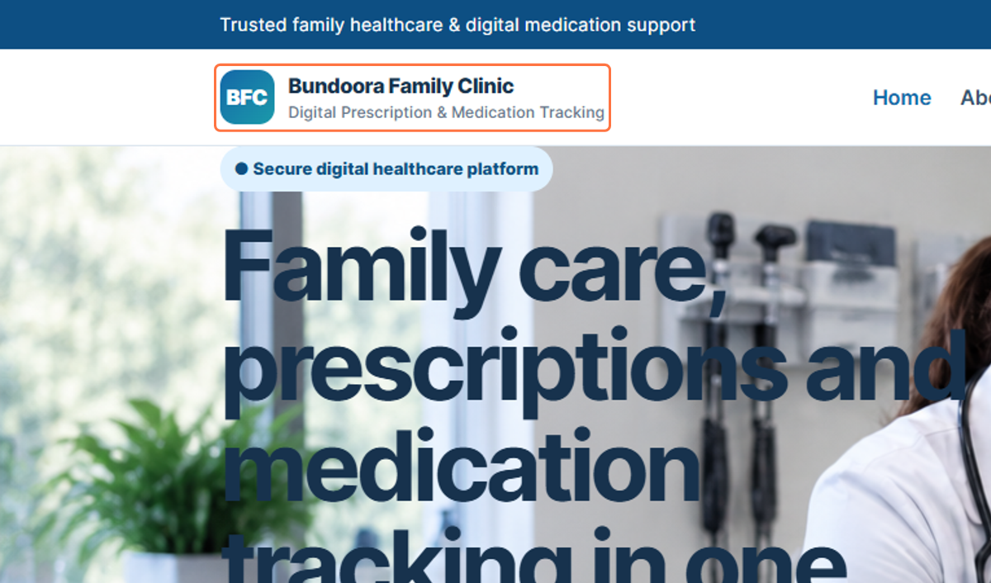
Figure 37: Bundoora Family Clinic branding

38. Home
The Home option returns the visitor to the main landing section of the Bundoora Family Clinic website. This section presents the primary introduction to the clinic and its digital healthcare services.
77. Select Home from the navigation menu.
78. Review the main landing-page information.
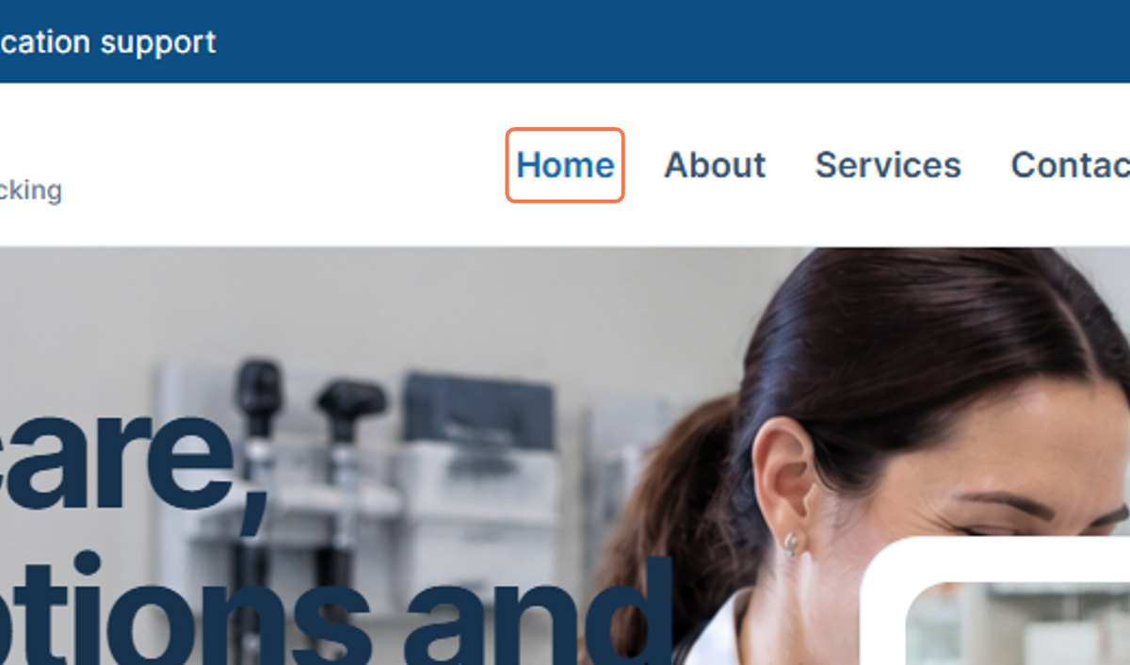
Figure 38: Home navigation

39. About
The About option provides information about the Bundoora Family Clinic and the purpose of the digital healthcare platform. It allows visitors to learn more about the clinic before using the secure portal.
79. Select About from the navigation menu.
80. Review the clinic information presented in the About section.
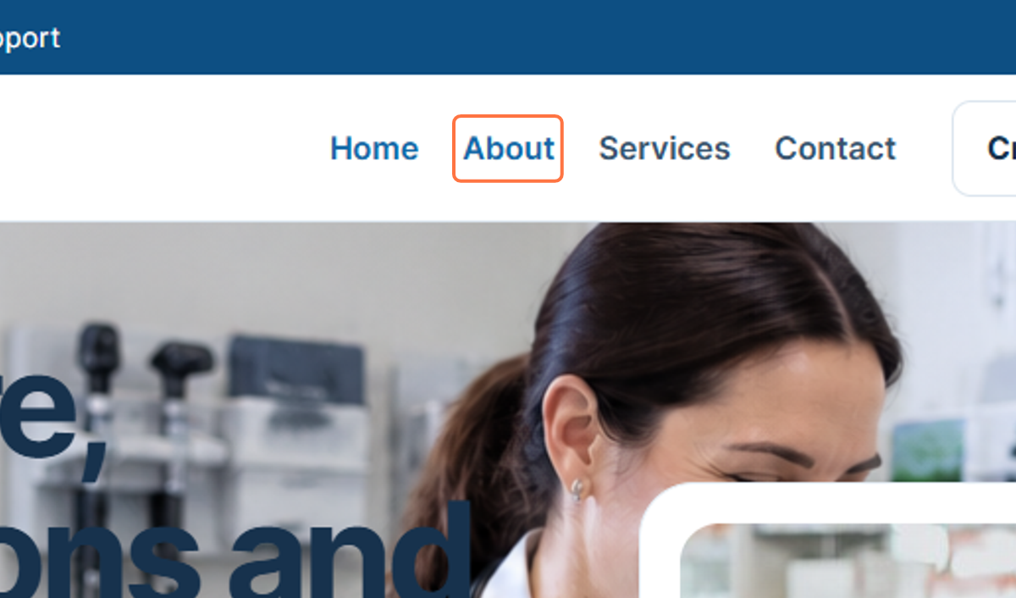
Figure 39: About navigation

40. Services
The Services option provides information about services offered through the Bundoora Family Clinic website. It helps visitors understand the digital prescription, medication tracking, and other clinic-related services available.
81. Select Services from the navigation menu.
82. Review the services information displayed on the page.
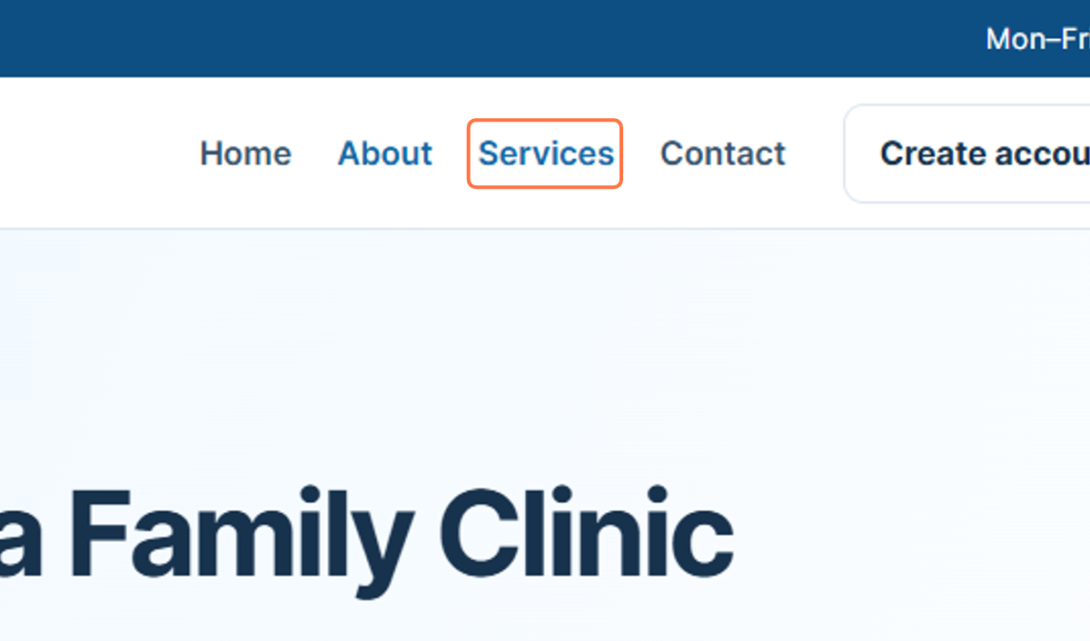
Figure 40: Services navigation

41. Contact
The Contact option gives visitors access to clinic contact information and enquiry options. This section can be used when a visitor needs to communicate with the clinic or request further information.
83. Select Contact from the navigation menu.
84. Review the available contact or enquiry information.
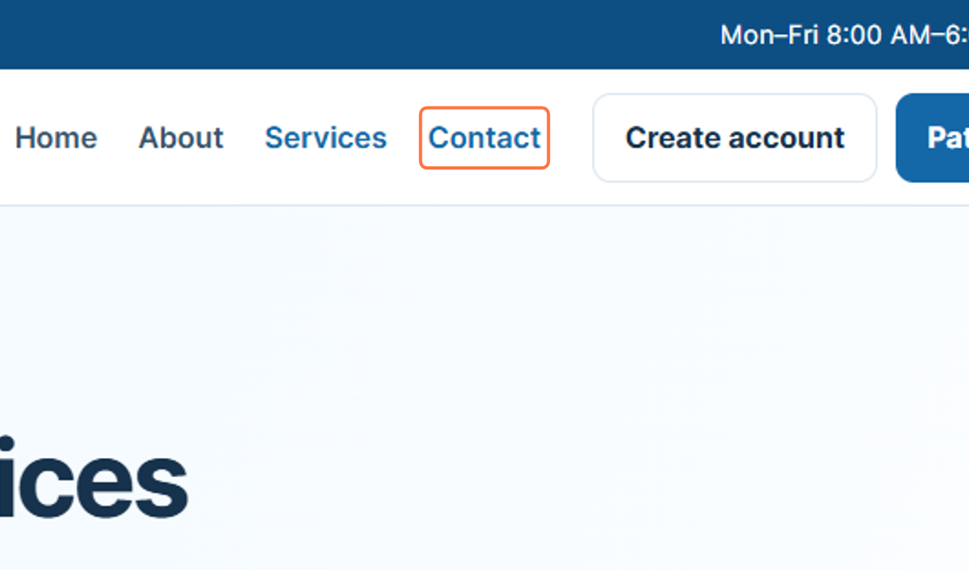
Figure 41: Contact navigation

42. Open Secure Portal
The Open secure portal button provides access from the public website to the protected clinic system. The secure portal is intended for authorised users who need to access role-based functions.
85. Locate the Open secure portal button.
86. Select Open secure portal to continue to the protected system.
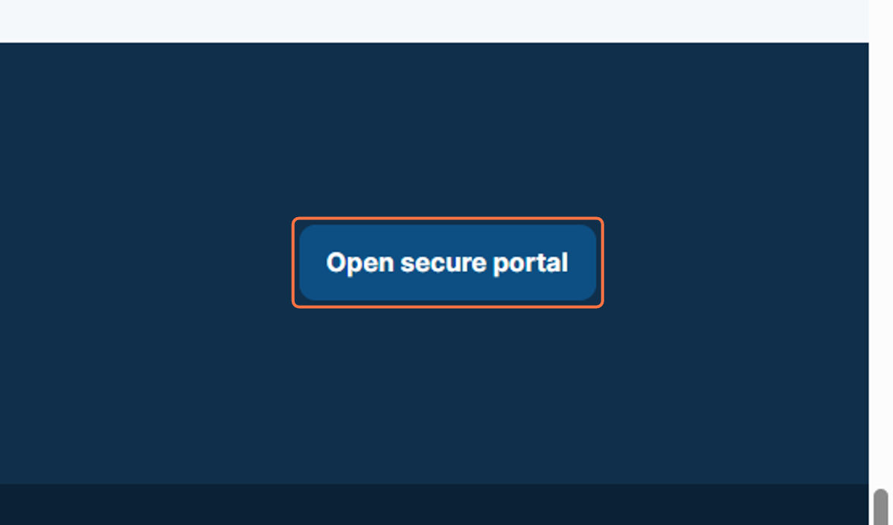
Figure 42: Opening the secure portal

43. Footer - Bundoora Family Clinic
The website footer repeats the Bundoora Family Clinic name and branding. This area provides a consistent clinic identity while users navigate through the lower part of the public website.
87. Scroll to the website footer.
88. Review the Bundoora Family Clinic name and branding.
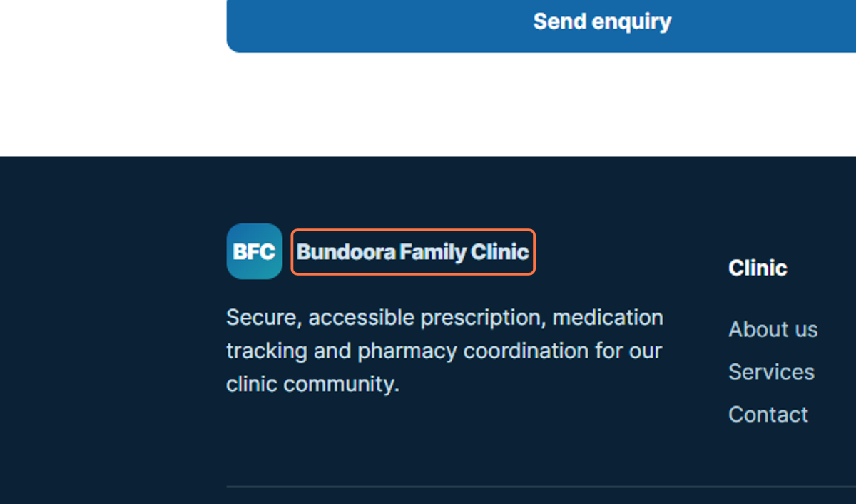
Figure 43: Bundoora Family Clinic footer branding

44. Footer Description
The footer includes a short description of the clinic platform. It explains that the system supports secure and accessible prescription, medication tracking, and pharmacy coordination for the clinic community.
89. Locate the descriptive text in the footer.
90. Review the summary of the clinic’s digital services.
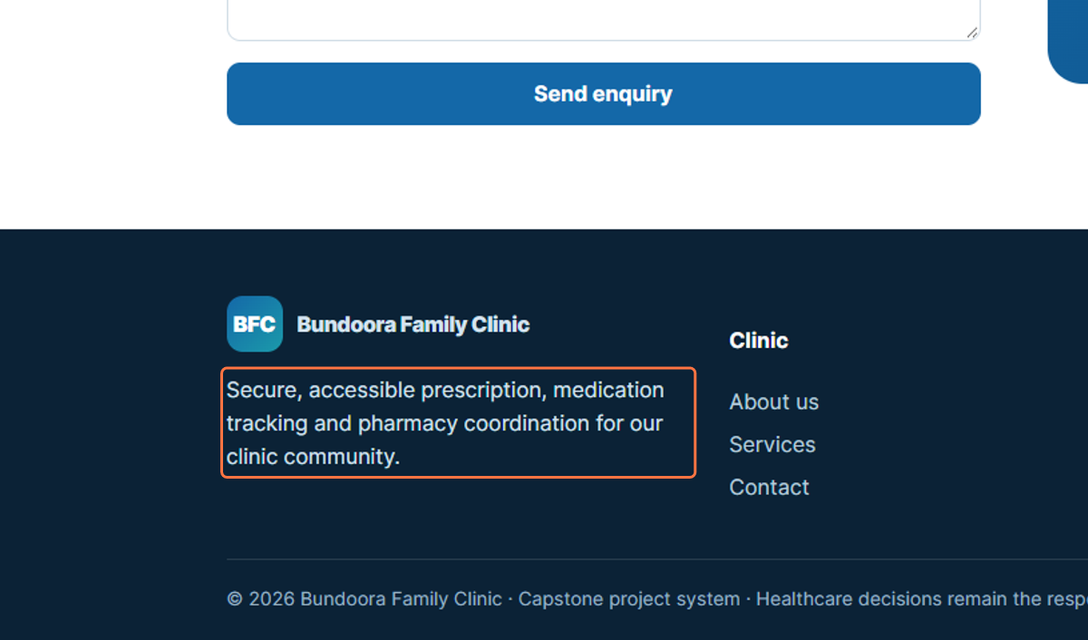
Figure 44: Clinic service description in the footer

45. Footer - Clinic Links
The Clinic section in the footer groups useful website links together. This provides another way for visitors to access clinic information from the bottom of the page.
91. Locate the Clinic heading in the footer.
92. Review the links listed under the Clinic section.
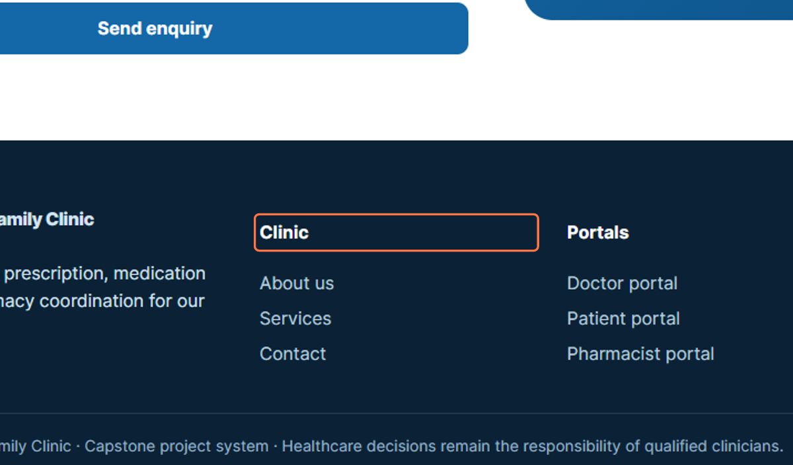
Figure 45: Clinic links in the footer

46. Footer - About Us
The About us link in the footer provides another navigation path to information about the clinic. This is useful when the visitor has reached the bottom of the page and wants to return to the clinic information section.
93. Select About us from the footer.
94. Review the clinic information displayed after navigation.
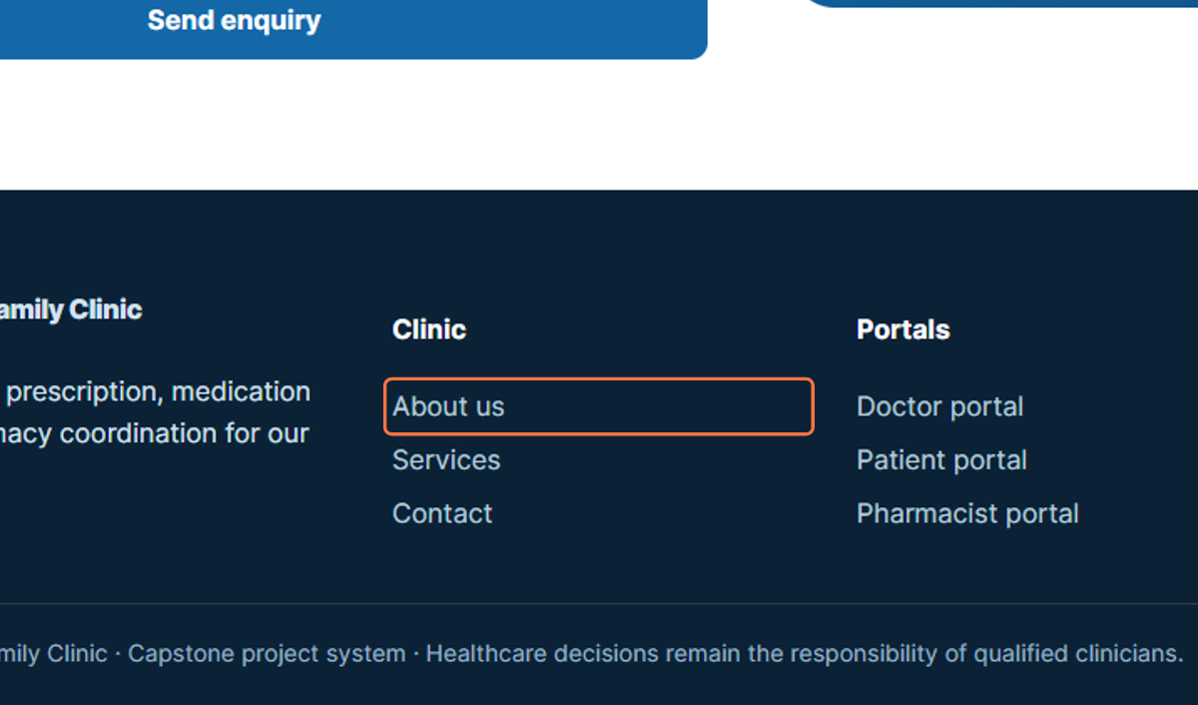
Figure 46: About us footer link

47. Footer - Services
The Services link in the footer provides direct access to information about the clinic’s available services. It duplicates the main navigation option so users can access services without returning to the top of the page.
95. Select Services from the footer.
96. Review the services section after navigation.
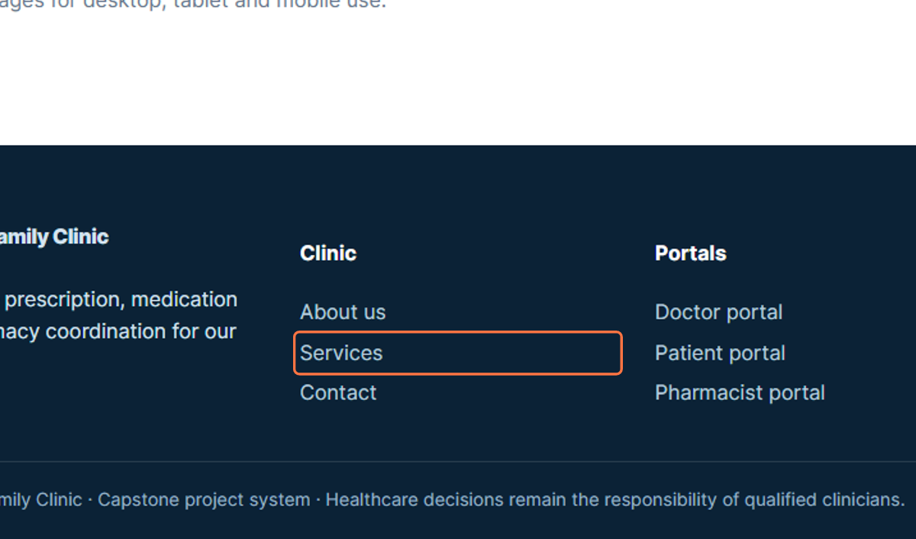
Figure 47: Services footer link

48. Footer - Contact
The Contact link in the footer provides direct access to the clinic contact section. It allows visitors to reach enquiry and contact information from the bottom of the website.
97. Select Contact from the footer.
98. Review the clinic contact information or enquiry section.
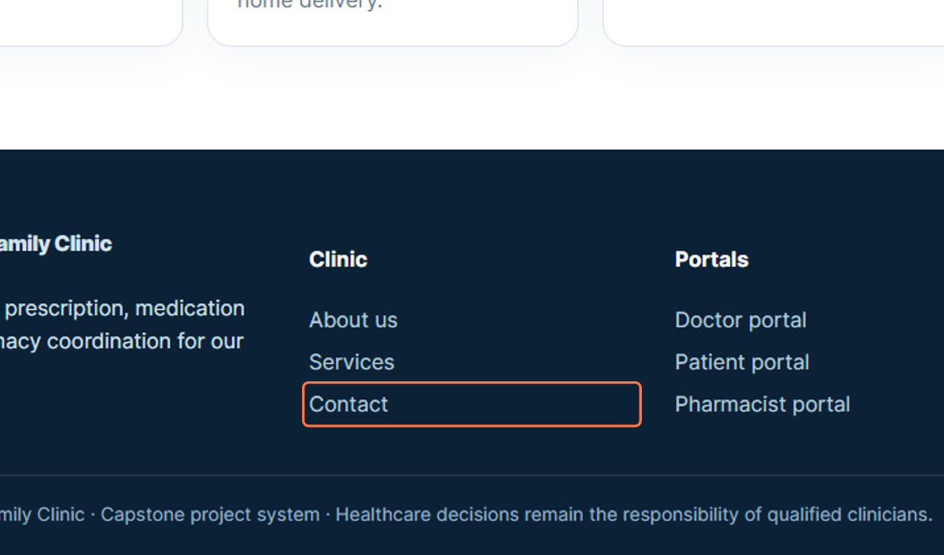
Figure 48: Contact footer link

49. Signing In - Email Address
The patient workflow begins on the Bundoora Family Clinic login page. The patient enters the registered patient email address in the Email address field so the system can identify the correct account.
99. Open the Bundoora Family Clinic sign-in page.
100. Select the Email address field and enter the patient account shown in the workflow: patient@bundoora.test.
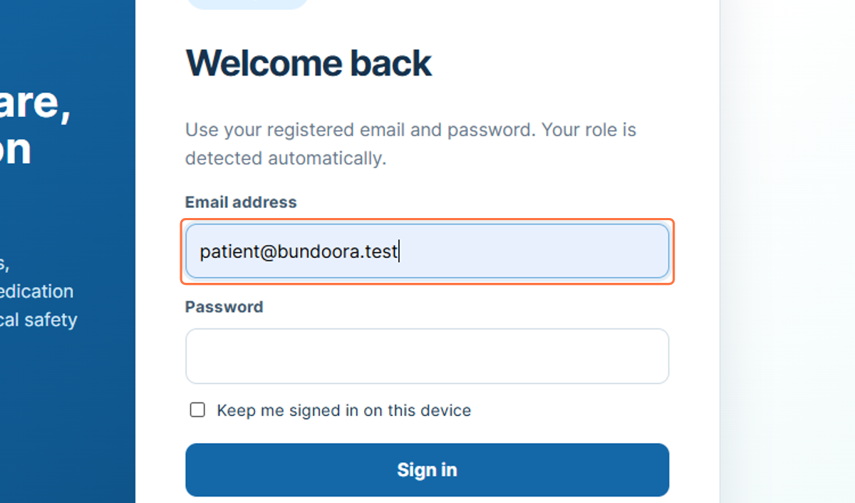
Figure 49: Entering the patient email address

50. Signing In - Password
After the email address has been entered, the patient provides the password for the account. The password is displayed as masked characters to protect the login credentials.
101. Select the Password field.
102. Enter or paste the password associated with the patient account.
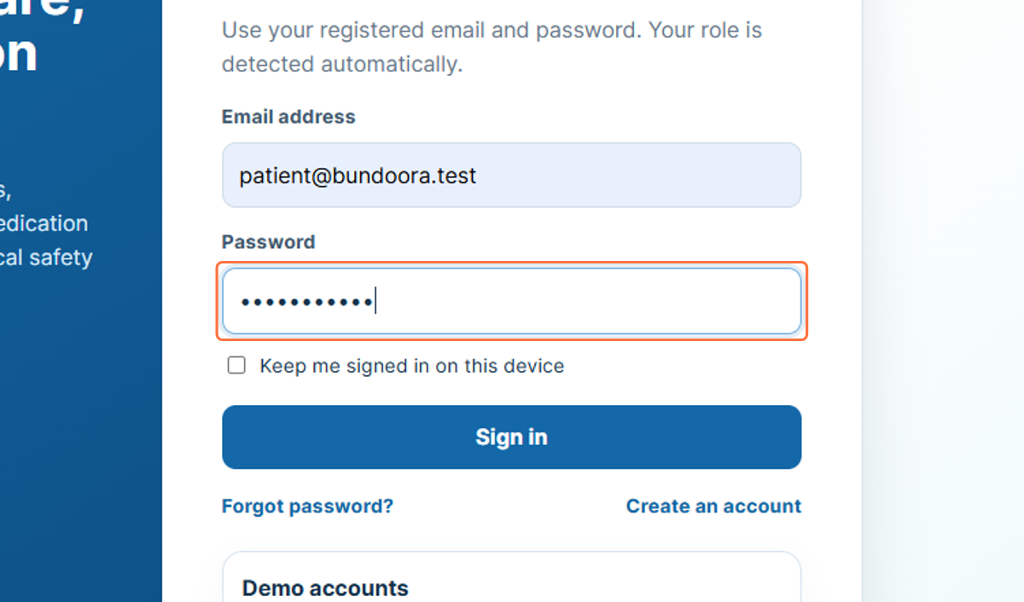
Figure 50: Entering the patient account password

51. Signing In - Submit Credentials
Selecting Sign in submits the entered credentials for authentication. When the credentials are accepted, the system opens the Patient Dashboard and provides access to patient-specific functions.
103. Check that the email address and password fields are completed.
104. Select Sign in.
105. Wait for the Patient Dashboard to load.
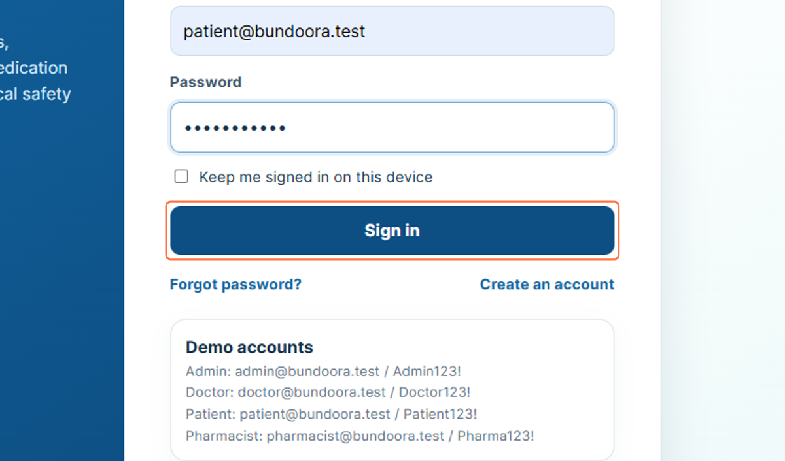
Figure 51: Selecting Sign in

52. Patient Profile Area
The profile card in the left sidebar identifies the patient who is currently signed in. In the workflow, the account is shown as Jordan Brown with the role Patient, allowing the user to confirm that the correct account is active.
106. Confirm the patient name shown in the sidebar.
107. Confirm that the role displayed is Patient.
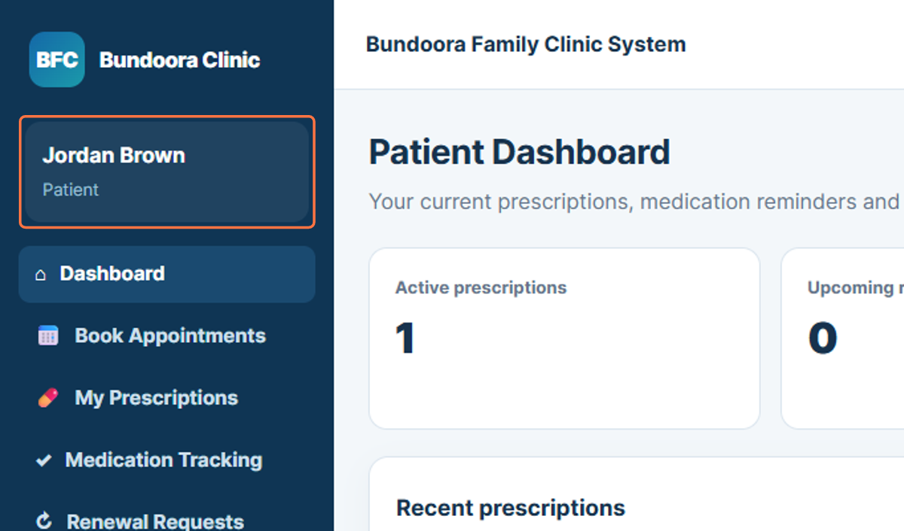
Figure 52: Patient identity and role shown in the sidebar

53. Dashboard
The Patient Dashboard is the main overview page for the patient account. It presents summary information such as active prescriptions, upcoming renewals, and recent prescription activity.
108. Select Dashboard from the sidebar.
109. Review the summary information and recent prescription activity.
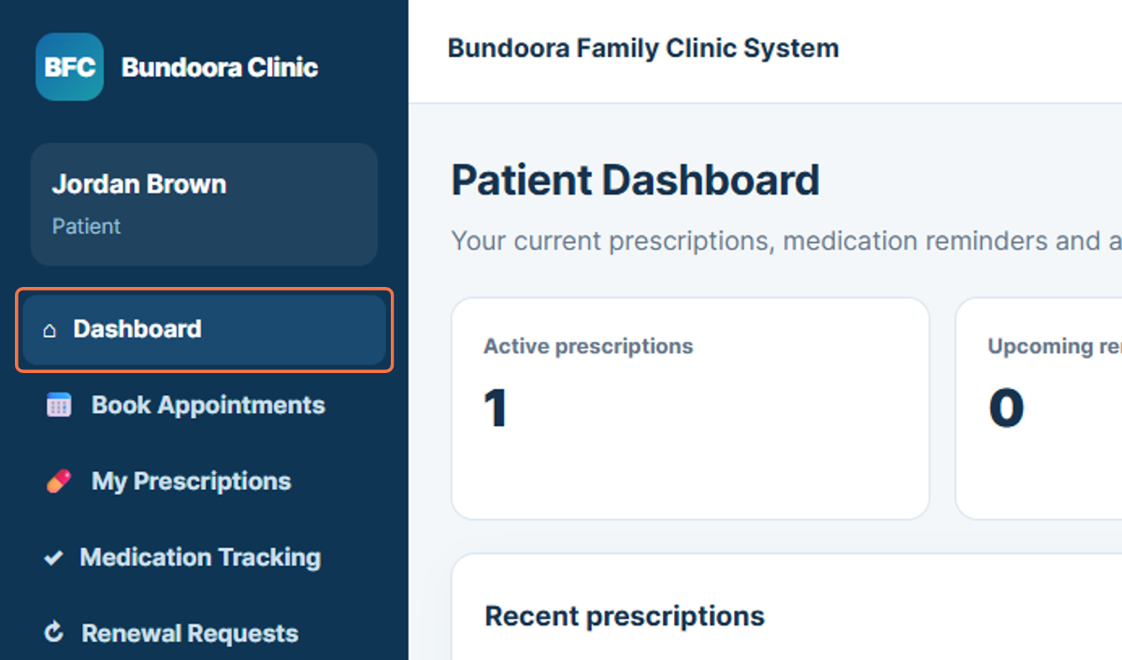
Figure 53: Patient Dashboard navigation

54. Book Appointments
Book Appointments allows the patient to select a doctor and choose an available consultation time. The workflow shows an appointment booking area where the patient can select a doctor, preferred date, and available hourly time slot.
110. Select Book Appointments from the sidebar.
111. Choose the doctor and preferred appointment date.
112. Review the available appointment time slots and continue with the required booking.
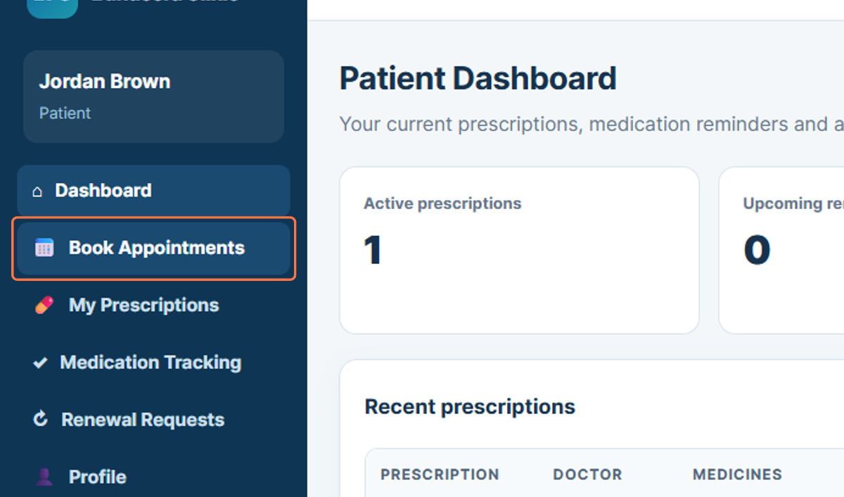
Figure 54: Opening Book Appointments

55. My Prescriptions
My Prescriptions provides access to the patient’s active and past prescription records. The page shown in the workflow displays prescription details together with the doctor and medicine information.
113. Select My Prescriptions from the sidebar.
114. Review the available prescription records and medicine details.
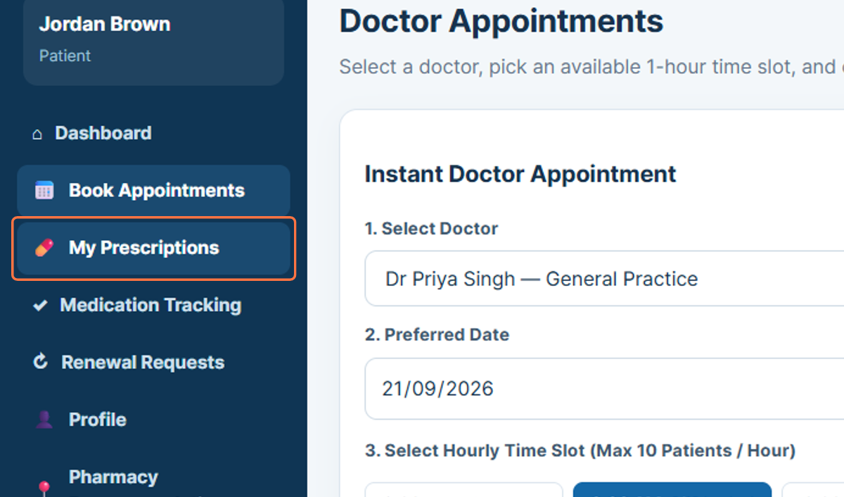
Figure 55: Opening My Prescriptions

56. Medication Tracking
Medication Tracking allows the patient to review prescribed medicines and medication-related information. This section supports ongoing monitoring of medicine schedules and medication status.
115. Select Medication Tracking from the sidebar.
116. Review the listed medicines, dosage information, and schedule details.
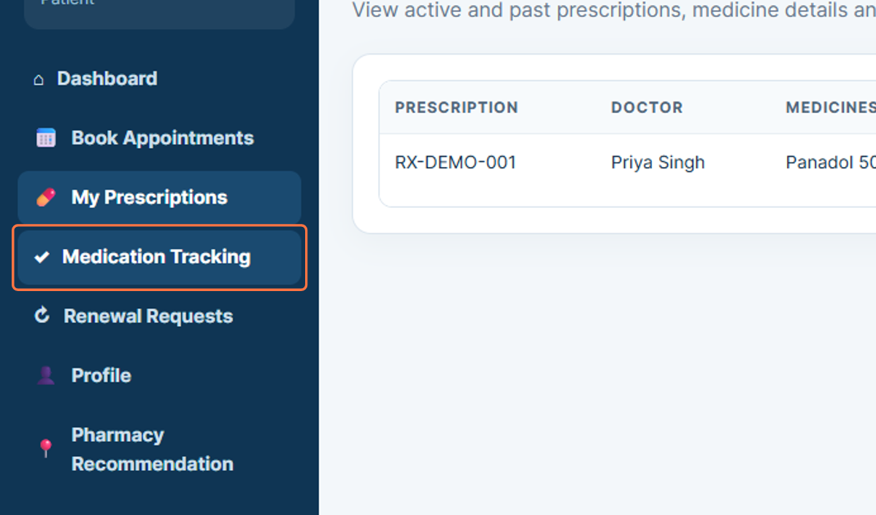
Figure 56: Opening Medication Tracking

57. Renewal Requests
Renewal Requests allows the patient to request a prescription renewal from the doctor. The workflow shows a prescription selection field and a notes area where the patient can provide the reason or additional information for the renewal request.
117. Select Renewal Requests from the sidebar.
118. Choose the prescription that requires renewal.
119. Enter any relevant notes for the doctor.
120. Submit the renewal request when the details are complete.
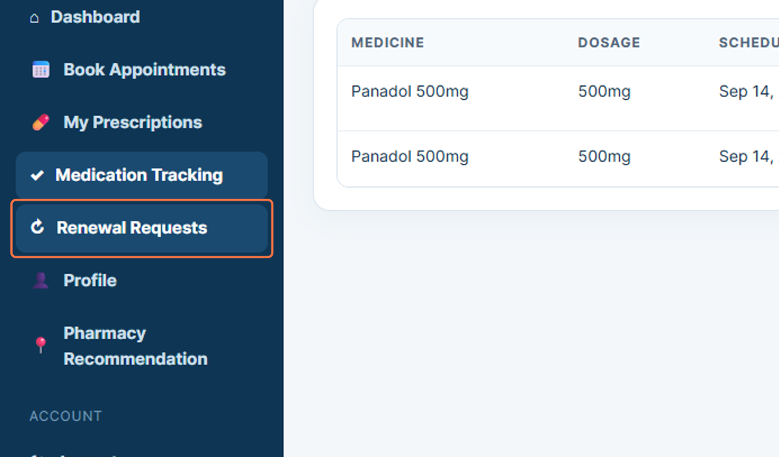
Figure 57: Opening Renewal Requests

58. Profile
The Profile section displays the patient’s personal information stored in the system. The workflow shows details such as date of birth, address, and Medicare number.
121. Select Profile from the sidebar.
122. Review the personal information displayed in the profile area.
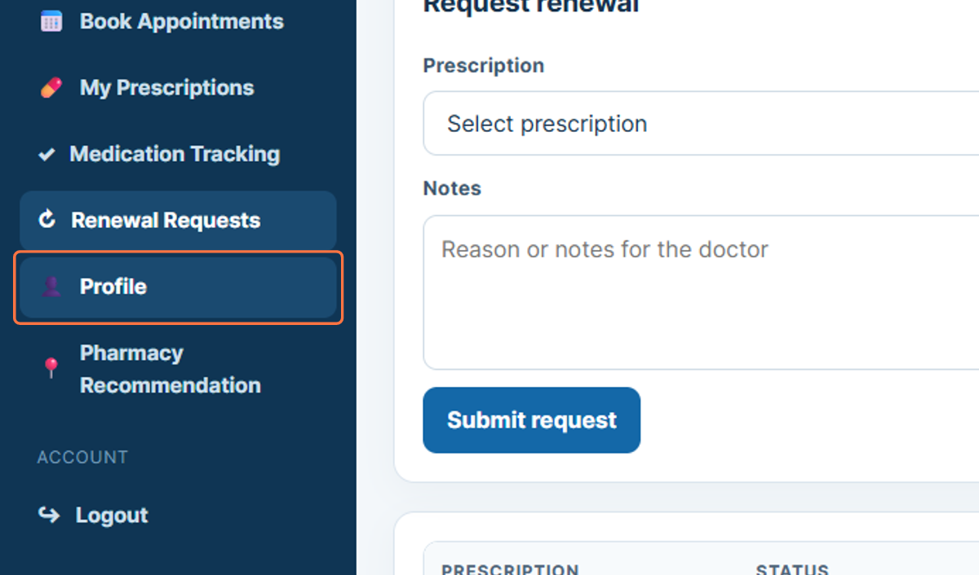
Figure 58: Opening the Patient Profile

59. Pharmacy Recommendation
Pharmacy Recommendation provides a way for the patient to search for a suitable pharmacy. The workflow shows a Find pharmacy option that can be used to locate pharmacy choices related to the patient’s medication needs.
123. Select Pharmacy Recommendation from the sidebar.
124. Review the pharmacy recommendation area.
125. Select Find pharmacy when a pharmacy search is required.
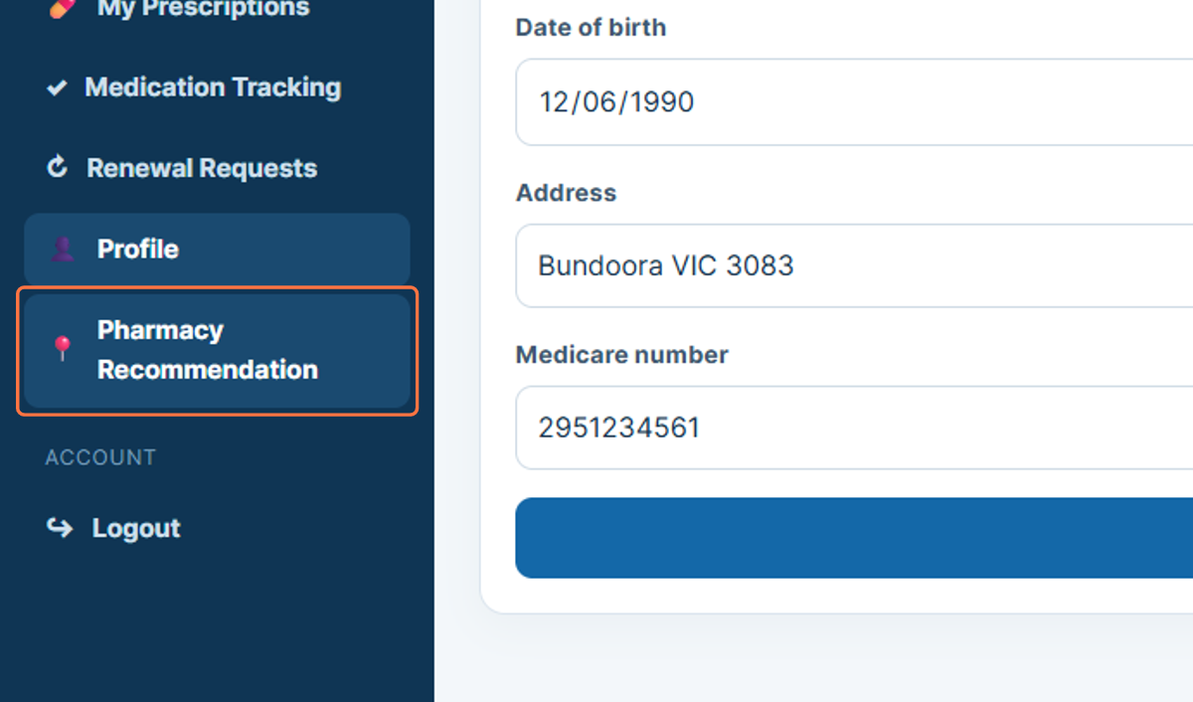
Figure 59: Opening Pharmacy Recommendation

60. Logout
Logout ends the current patient session. Signing out after reviewing prescriptions, renewals, or personal information helps prevent another person from accessing the active patient account.
126. Select Logout from the sidebar.
127. Confirm that the patient session has ended.
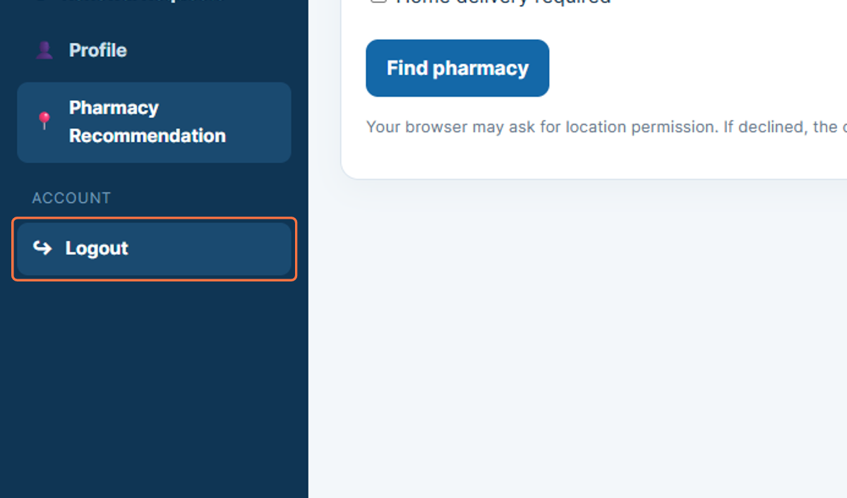
Figure 60: Logging out of the Patient Portal

